Sportschule

Sportschule Höxter e.V., Rodewiekstr. 8, 37671 Höxter

To all
Organisations, Sports Schools and Clubs

Höxter e.V.

Invitation to an international sparring seminar
24th & 25th September in Hoexter, Germany

For the fourth time Grandmaster Ung Kim Lan and Tomasz Barada will lead this seminar

Seminar Leaders:
Grandmaster Ung Kim Lan 9. Dan  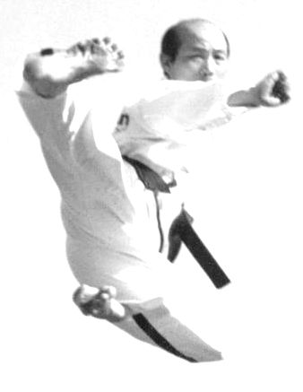 | Tomasz Barada 5. Dan
International Grandmaster and Master Trainer  German National Team Coach  ITF Hall of Fame “Best Coach 2007” |  | ITF-Taekwon-Do  3x World and 6x European Champion  3 x King of Tokyo Taekwon-Do  Slovenian National Team Coach  WAKO Kickboxing  5x World- and 6x European Champion

All interested athletes, organization, schools and clubs from all over the world are invited to take part in this seminar.
Details for the seminar can be found in the application form.

Yours sincerely,

Uwe Lange
School Secretary

