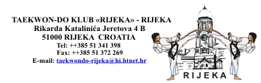

4th CROATIA OPEN TAEKWON-DO CHAMPIONSHIP
RIJEKA – CROATIA , 14th October 2006

Dear Sir/Madam,

It is with great pleasure that, in behalf of the Croatian Taekwon-do Union, I would like invite You,
Your instructors and students to The 4th CROATIA OPEN TAEKWON-DO CHAMPIONSHIP,
to be held on Saturday, the 14th of October 2006 in RIJEKA – CROATIA.

Competition will be organized for:

JUNIORS: MALE AND FEMALE UP TO 15 YEARS OLD ( the oldest born in 1992)

JUNIORS: MALE AND FEMALE 15 TO 18 YEARS OLD ( the oldest born in 1988)

Place of event: Sports Hall «DVORANA MLADOSTI» in Rijeka, TRSAT,Viktora Bubnja bb
(The same Hall hosted European Championships 2003)

The Year 2006 is very special for us, because 30 Years ago we started with practise taekwon-do in
our school in RIJEKA.

We will do our best to meet your expectations and make this sport event enjoyable for everyone.

In the case you have any questions do not hesitate and call or e-mail taekwondo-rijeka@hi.t-com.hr
as soon as possible.

WELCOME TO RIJEKA – WELCOME TO CROATIA !

Yours in Taekwon-Do,

Milan Spasojević
Secretary General

