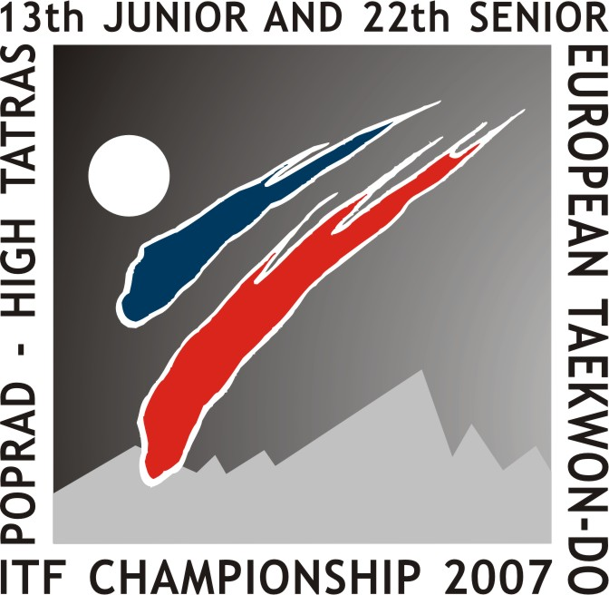
13 ^{th} Junior and 22th Senior
Taekwon-do ITF European Championship
April 27 – 29 th, 2007
Poprad – High Tatras, Slovakia

Official Invitation!

Presov, May 5th, 2006

Dear A.E.T.F. – Members!

On behalf of the Slovak Union of Taekwon-do ITF and All Europe Taekwon-do Federation,
we have the honour to invite you to the

13 ^{th} Junior and 22th Senior Taekwon-do ITF European Championship

to be held in Poprad – High Tatras on April 27th to 29th, 2007

The Championship shall take place in „Poprad Arena“ Poprad – Slovakia.

Slovakia is situated in the middle of Europe. The capital city is Bratislava. Airports with international conections are in Bratislava, Poprad and Kosice. Official currency is Slovak crown (Skk). Average temperature varies from +10.4 ⁰C to -3.7 ⁰C.

Poprad is the third largest town of the eastern Slovakia. www.poprad.sk
The town of High Tatras is a central part of The National Park which coveres an area of 74,111 hectacres. It is the oldest and largest National Park in the Slovak Republic. www.tatry.sk, www.vysoketatry.sk, www.slovakiatourism.sk

Participants and officials shall be accomodated in Poprad and in High Tatras.

Please find enclosed the schedule of the championship with all the necessary details.

We are looking forward to your participation!

With kind regards

Martina Soltisova Semesiova Daniela Palascakova
President of SUTKD ITF General Secretary of SUTKD ITF

13 ^{th} Junior and 22th Senior
Taekwon-do ITF European Championship
April 27 – 29 th, 2007
Poprad – High Tatras, Slovakia

Subject
13 ^{th} Junior and 22th Senior Taekwon-do ITF European Championship

Chamionship Dates
From 27 April to 29 April 2007

Venue
Poprad Arena
Poprad Juh 3
Uherova street
Poprad – Slovakia

Promoter
All Europe Taekwon-do Federation (A.E.T.F.)
www.itfeurope.org

Organizer
Slovak Union of Taekwon-do ITF
www.sztkd-itf.sk

President of Organizing Committee
Martina Soltisova Semesiova
President of Slovak Union of Taekwon-do ITF

Bajkalská 12,
08001 Prešov, Slovakia
Tel.: 00421 905 84 11 28
Fax: 004721 51 77 456 63
e-mail: msemesiova@gmail.com

General Secretary
Daniela Palascakova
General Secretary of Slovak Union of Taekwon-do ITF

Antona Prídavku 22,
08001 Prešov, Slovakia
Tel.: 00421 902 40 92 94
Fax.: 00421 51 77 136 76
e-mail: palascak@unipo.sk

13 ^{th} Junior and 22th Senior
Taekwon-do ITF European Championship
April 27 – 29 th, 2007
Poprad – High Tatras, Slovakia

General informations
Arrival Date
All Groups should arrive on 26 April 2005 (or before). Arrivals before 16⁰⁰ hrs in Sport hall Poprad Arena for accreditation, weight control and payments of the following fees:
- Competitors entry fee
(both individuals and team members): Euro 100,00
- Team entry fee: Euro 50,00 per team
- Hotel accomodation see chapter on Hotel accommodation.

Preliminary timetable

Thursday 26th, 2007
14.00 – 18.00 training facilities
18.00 – 19.30 draw and coach meeting
19.30 – 20.30 umpire meeting
21.00 dinner

Friday April 27th, 2007
06.30 – 08.00 breakfast
09.00 – 15.30 competition / finals / medal awarding
14.30 – 16.30 lunch break
18.00 – 21.00 AETF Congress
21.00 dinner

Saturday April 28th, 2007
06.30 – 08.00 breakfast
09.00 – 13.30 competition/ finals / medal awarding
13.00 – 14.30 lunch break
15.30 – 17:30 competition / finals / medal awarding
18:00 – 18:40 official opening ceremony
18:40 – 20:30 competition / finals / medal awarding
21.00 dinner

Sunday April 29th, 2007
06.30 – 08.00 breakfast
09.00 – 13.30 competition / finals / medal awarding
13.00 – 14.30 lunch break
15.30 – 20.00 competition / finals / medal awarding
20.00 – 20.30 closing ceremony
21.00 dinner
22.30 party

Monday April 30th, 2007
Breakfast and departure or stay for a holiday.
13 ^{th} Junior and 22th Senior
Taekwon-do ITF European Championship
April 27 – 29 th, 2007
Poprad – High Tatras, Slovakia

Hotel accomodation

Accomodation will be in hotels: Hotel AquaCity Poprad www.aquacitypp.sk, Hotel Atrium www.atriumhotel.sk, Grand Hotel Starý Smokovec www.grandhotel.sk, Hotel Branisko, Palace www.tatry.sk The basic price for competitors 50 Euro per night, per person.

Price include the following:
- full board accomodation,
- chapionship ID card,
- free training facilities (from 26th April to 29th April 2007),
- free entrance to the sport hall,
- medical assistance during the competition days (only for competitors)
- VIP banquet (details later).

In the order of officiate in the Championship each country shall book the hotel accommodation through the organization committee of the championship.
Those countries not booking in the hotel accommodation through the organization committee of the championship shall pay Euro 100.00 per person in order to receive the ID card. Without ID card, any person can not to entries in the Sport Hall.

Competition Rules

According to the AETF Competition Rules.

Coaches
- must wear either a training suit or a T-shirt and pants and running shoes while coaching.
- only one (1) coach of a country is allowed entering the coaching zone at the same time.
- only a coach can present an official protest.
- not more than two (2) coaches per country will have access to the drawing and to the coaches meeting on Thursday April 26th 2007 at 18.00-19.30.
Umpires:
- Umpires will be accommodated in the Umpire/VIPs hotel.
- The organization will pay a 5 days/4 nights hotel accommodation including full board (no drinks included) from Thursday April 26th 2007 to Monday April 30th 2007 to a maximum of two (2) Umpires for each participating country.
- Other Umpires wishing to participate must pay their hotel accommodation according above mentioned arrangements.
- Umpires must attend the umpire meeting on Thursday April 26th 2007 at 19.30 – 20.30, at 19.30 hrs in the Umpire Hotel dressed as written in the ITF Umpire rules.

13 ^{th} Junior and 22th Senior
Taekwon-do ITF European Championship
April 27 – 29 th, 2007
Poprad – High Tatras, Slovakia

- Umpires not present at the umpire meeting on Thursday April 26th 2007, at 19.30 hrs shall be removed from the umpire list and be accommodated in the competitors hotel – they therefore shall pay their own expenses.
Arrivals

Plane
Countries arriving by plane to Poprad, have to see at page www.airport-poprad.sk, www.skyeurope.com
Countries arriving by plane to Kosice, have to see at page www.airportkosice.sk
- There are liaison flights to Kosice from the following airports: Bratislava, Prag, Vien.
Countries arriving by plane to Bratislava, have to see at page www.letiskobratislava.sk/flashContent/default3.html
- There are liaison flights to Bratislava from the following airports: Manchester (Terminal 1), London (Stansted, Luton), Amsterdam (Schiphol), Paris (Orly Sud), Stuttgart, Zurich, Milano (Orio al Serio, Bergamo), Roma (Fiumicino), Warsaw (Etiuda Terminal), Berlin (Schonefeld), Brusel, Kyjev, Moscow, Kodan, Zadar, Nice, Barcelona, Venecia, Split, Dubrovnik, Ateny, Prag.

Train
Countries arriving by train, have to see at page www.zsr.sk/generate_page.php?page_id=264, www.slovakrail.sk
Car
Countries arriving by car or bus see at the map.
Expressway D1

Visa

By now the following countries need a visa for entering Slovakia:

Albania, Bosnia-Herzegovina, Macedonia, Moldavia, Ukraine.

Travellers from these countries must contact the Slovak embassy in their country not later than 90 days before the championship to apply for a visa.

You also must send a list with the names (fIrst name and last name), dates of birth and the dates of issue and expiry of the passports of all those travelling to the Organizing Committee not later than 90 days before the championship.

You must name one person out of your group (giving the telephone - number, the fax number and the email address of this person), who will be at the disposal for further inquiries to the representations abroad.

13 ^{th} Junior and 22th Senior
Taekwon-do ITF European Championship
April 27 – 29 th, 2007
Poprad – High Tatras, Slovakia

www.sztkd-itf.sk/euros2007

Deadlines for following items

Application forms and photos of all participants / others must be send before or on the deadline
of 31st March, 2007
to the e - mail
euros@sztkd-itf.sk
msemesiova@gmail.com

