I.T.F. Tournament & Umpire Course
March 29th – March 30th, 2008
Cologne, Germany

I.T.F. Country Members
Dear Masters and Instructors,

On behalf of the ITF Tournament and Umpire Committee and ITF Germany, it is our great pleasure to invite all ITF Members to join us in the first session of the all new, official ITF Umpire Training Course.
This course will be held on March 29th & 30th, 2008 in beautiful Cologne, Germany.

Open to all Back Belt members 21 years of age or older, holding a minimum of 3rd Degree Black Belt, this seminar will be a comprehensive and exciting two day event, covering all aspects of Umpire training in both an informative discussion and practical exercise format, led by the new ITF Tournament and Umpire Committee.

This exciting new program will be conducted by the ITF Tournament & Umpire Committee:

- ITF Tournament & Umpire Committee Chairman: Master Alberto Katz (Argentina)
- AETF Vice-President and Umpire Committee Member: Master Coos van den Heuvel (Netherlands)
- Umpire Committee Member: Mr. Kurt Ottesen (Canada)

The skills and knowledge presented in this seminar will help to elevate and standardize the quality of Umpires around the world, and help us create a more professional, fair and enjoyable tournament experience for all our members!

Included in this seminar will be hands on experience and training with the new ITF approved Electronic Scoring System. All participants will also receive the new, official ITF Umpire Training Manuals and Tournament Rules Handbooks.

Please find attached all of the information regarding this seminar, registration and accommodations. If you have any questions or concerns, please do not hesitate to contact Master Paul Weiler, host and organizer of this event.

The ITF Tournament and Umpire Committee and the Directors of ITF Germany are very proud to be able to provide this exciting training opportunity to all the members of the ITF and warmly look forward to having everyone come together in the spirit of brotherhood, goodwill and learning!

Yours in TKD

Master Alberto Katz
Chairman: ITF Tournament & Umpire Committee


I.T.F. Tournament & Umpire Course
March 29th – March 30th, 2008
Cologne, Germany

DATES | March 29th – March 30th, 2008
SEMINAR  LOCATION | Sportshall and Auditorium Gereonsmühlengasse 4
PRESENTED BY | International Taekwon-Do Federation Tournament and Umpire Committee
CONDUCTED BY | ITF Tournament and Umpire Committee  - Chair : Master Alberto Katz  - Member : Master Coos van den Heuvel  - Member Mr. Kurt Ottesen
OPEN TO | ITF Certified Black Belts  - Black Belt 2rd Degree and above  - 21 years of age and older  Participants must present their ITF Certificate Number (Small ITF Black Belt Card)
REQUIRED ITEMS | All participants are required to bring:  - ITF Official’s Attire  (Blue Jacket, blue slacks, white shirt, plain blue tie, white socks, white shoes)  - ITF Dobok  - Pen  - Notebook
MATERIALS PROVIDED | - Umpires Training Manual  - Official’s Handbook  - Electronic Scoring System
CERTIFICATION | Certificates of Training will be awarded upon successful completion of the course, allowing participants to APPLY for their ITF Class “A” or Class “B” Umpire Certificate,  upon submission of the appropriate application forms and fees to the Secretary General of the ITF.

SEMINAR GOALS | Specifically, this seminar aims to:  - Introduce the official Electronic Scoring System for both Patterns and Sparring.  - Align umpires, coaches and technical directors around the world with current umpiring and tournament organizational matters.  - Prepare and qualify Class “A” Umpires (4th degree and above) for officiating in the upcoming World Cup Championships, to be held in: Italy 2008, and Argentina 2009.  - Prepare and qualify Class “A” Umpires (4th degree and above) for officiating in the upcoming European Championships to be held in Poland, in May 2008
SCHEDULE | Arrival: Friday, March 28th, 2008  Kommerz Hotel,  Johannisstraße 30 – 34,  50668. Köln, Germany  Tel. ++49-221- 16 10-0  Fax ++49-221-16 10-122  All fees (seminar and accommodation) must be paid upon arrival  Seminar: Saturday, March 29th, 2008  09.00 – 11.00 Seminar  11.00 – 11.30 Coffee Break  11.30 – 13.00 Seminar  13.00 – 15.00 Lunch  15.00 – 17.00 Seminar  17.00 – 17.30 Coffee Break  17.30 – 19.30 Seminar  Sunday, March 30th, 2008  09.00 – 11.00 Seminar  11.00 – 11.15 Coffee Break  11.15 – 12.30 Seminar  12.30 Departure
SEMINAR FEES | According to the I.T.F. By-Laws, Course fees are:  € 100.00 Seminar Fee  plus  € 30.00 Inscription fee.  Special agreement for accommodation fees have been made with the Seminar Hotel.
REGISTRATION DEADLINE | Registration may be made by either: mail, fax or email.  All registrations and reservations for hotel accommodations must be made on the official form, and received prior to January 31^{st,} 2008.  Please send all registrations and reservations to:  Master Paul Weiler  fax 00 49 221 63 67 863  e mail: p.weiler@itf-d.de

HOTEL ACCOMODATIONS | Special hotel accommodation rates have been arranged for the participants of this event  Kommerz Hotel,  Johannisstraße 30 – 34,  50668. Köln, Germany  Tel. ++49-221- 16 10-0  Fax ++49-221-16 10-122  Special Accommodation Rates:  - Double/Twin Room 44,50 € per day per person or  99.00 € per day  - Single room 60,00 € per day  Note 1: All accommodation and registration fees must be paid upon arrival, prior to check in.  Note 2: Rooms prices include breakfast  Note 3: After the deadline we are not able to guaranty availability of rooms or the special rate, therefore anyone registering after the deadline will have to find accommodations on your own.  Location: The Kommerz Hotel is located 100 m from the Main Railway Station  in Cologne (Hauptbahnhof) and 800 m from the Sportshall Gereonsmühlengasse in the heart of the beautiful city and within a walking distance to the old town with its fascinating pubs and restaurants and of course to the world famous Gotic Cathedral (Dom).  Other Hotels are also available at a greater expense.
ARRIVING IN COLOGNE | By plain:  - Fly to Cologne Airport (German Wings, HLX, Air Berlin)  - From there take Bus No. 170 to the Bus terminal Breslauer Platz/KöHauptbahnhof (HBF) (next to Kommerz Hotel)!  - The bus will be leaving Cologne Airport every 30 minutes or  - Take the Bus S-Bahn (S 13) to Köln Hauptbahnhof (HBF)  By train:  - Get off at Cologne Main Railway Station Hauptbahnhof = HBF)
ARRIVING IN COLOGNE | By car:  - Take the Autobahn A 3 from Frankfurt or Oberhausen in the direction of Cologne.  - From Autobahnkreuz Köln-Ost take the direction Köln-Zentrum (City – Centre) on Stadtautobahn.  - Direct after crossing the River Rhine leave the Stadtautobahn and turn right on Konrad Adenauer-Ufer.  - After 2 km turn right again on Goldgasse.  - You will see the Kommerz-Hotel on the left side (orange-coloured).



Map of Cologne

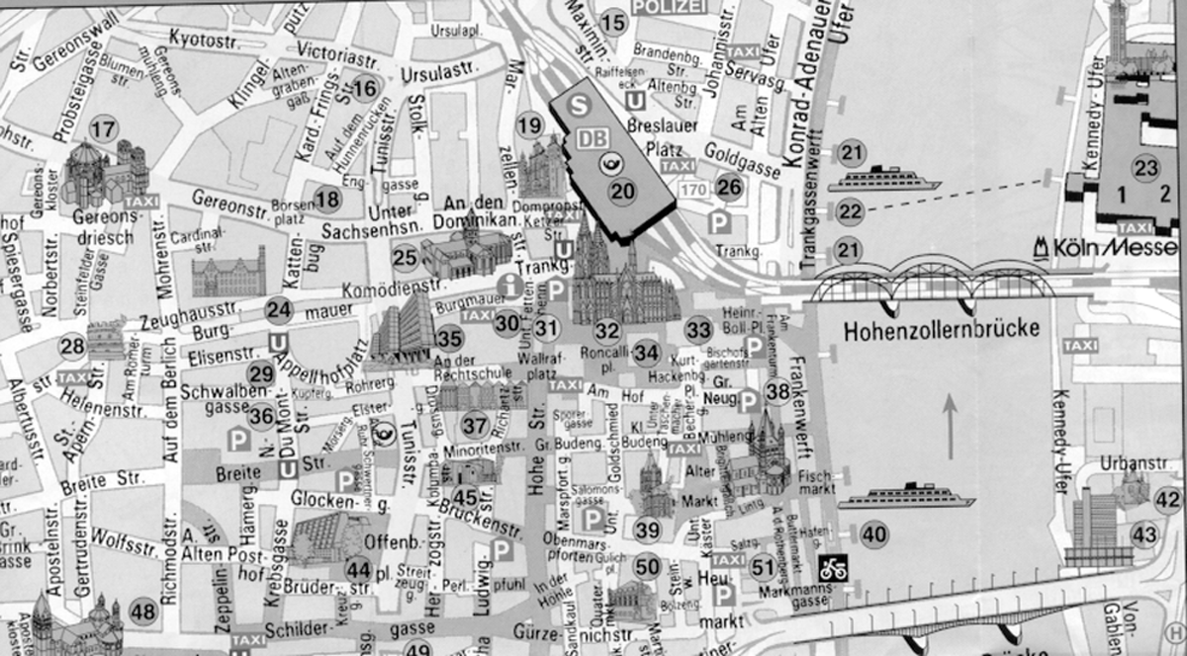
Sportshall and Auditorium
Gereonsmühlengasse
Kommerz-Hotel

ARRIVING AT THE SPORTSHALL  (Seminar Location) | - Pass by the Main Railway Station (Breslauer Platz),  - Turn left under the Railway Station (Ursulastraße)  - Follow Victoriastraße and Kyotostraße.  - You will see the sports hall on the left side of Kyotostraße.

COURSE CONTENT | FORMAT
Rules and Regulations | Discussion
Official’s Duties  - Jury President  - Members  - Referee  - Corner Officials | Discussion
Patterns  - General Notes  - Responsibilities  - System of Scoring  - Giving a Decision | Discussion  Practical  Electronic System
Sparring  - General Notes  - Responsibilities  - Point System  - Warnings  - Fouls | Discussion  Practical  Electronic System
Power Breaking  - General Notes  - Responsibilities  - Point System | Discussion  Practical
Special Technique  - General Notes  - Responsibilities  - Point System | Discussion  Practical
Traditional Sparring  - General Notes  - System of Scoring  - Giving a Decision | Discussion  Practical
Jury President  Jury Members | Discussion  Practical
Dispute Procedure | Discussion
Coaches | Discussion
Tournament Administration and Scheduling | Discussion
Question and Answer | Open Forum



International TaeKwon-Do Federation
”Teaching You the Art of Life”

Tournament and Umpire Committee

Course Registration and Hotel Reservation Form

I.T.F. Umpire Course
Cologne, Germany – 2008
Country
Organization
Responsible in Charge
Telephone: |  |  |  |  |  |  |  |  |  |  |  |  |  |  | Fax:
Email:
 |  | Family Name |  |  |  |  |  |  | Given Name |  |  |  |  |  |  |  |  |  |  | Degree /  Certificate # |  |  |  | Umpire Certificate #
1.
2.
3.
4.
5.
6.
7.
8.
I, |  |  |  |  |  |  |  |  |  |  | agree to register and reserve for a total of |  |  |  |  |  |  |  |  |  |  |  |  |  | persons:
 |  | (Responsible of Country/Organization/Individual)l |  |  |  |  |  |  |  |  |  |  |  |  |  |  |  |  |  |  | (Also Includes all visitors)
 |  |  |  |  |  |  |  | Double / Twin Rooms |  |  |  |  |  |  |  |  |  |  |  |  |  |  | Single Rooms
 |  | (Number of Rooms) |  |  |  |  |  |  |  |  |  |  |  |  |  |  | (Number of Rooms)
 | Arriving on |  |  |  |  |  |  |  |  | at |  | hrs |  |  |  | by
 |  |  |  |  | (Day / Month) |  |  |  |  |  |  | (Time) |  |  |  |  |  |  | (Plane, Train, Vehicle)
 | Departing on |  |  |  |  |  |  |  |  | at |  |  | hrs |  |  | by
 |  |  |  |  |  | (Day / Month) |  |  |  |  |  |  | (Time) |  |  |  |  |  | (Plane, Train, Vehicle)

