15.06.12

TO: All ITF Country Members.

Subject: Special International Instructors Course for the 10th anniversary , 2012 Israel.

Dear Madam/Sir,

The Israel Taekwon-do Association is celebrating it's 10th anniversary and we are delighted to invite you to a special International Instructors Course In honor of this occasion
To be held in the city of Tel-Aviv, Israel .

Date: November 30 – December 2, 2012

Venue: Sport hall Tel Aviv, Israel

The seminar will be conducted by the ITF Technical Committee:
G.Master Hector Marano (9th degree – Argentina).
G.Master Willem Jacob Bos (9th degree – Italy).
G.Master Ung Kim Lan (9th degree – Germany).

Schedule:

Friday, November 30, 2012 09:00 – 12:00 Seminar
12:00 – 13:00 Lunch
13:00 – 16:00 Seminar
20:00 Banquet

Saturday, December (Shabbat) 01, 2012 08:00 Trip to Jerusalem

Sunday, December 02, 2012 09:00 - 12:00 Seminar
12:00 – 13:00 lunch
13:00 – 16:00 Seminar
16:00 – 18:00 Dan Grading

Day trip to Jerusalem: The Israel Taekwon-do Association invite all the participants from the world to visit the beautifull and holy city of Jerusalem - free of charge.

Course fees: 2 kup up to VI degree: $150 course fees +$75 registration.
VII degree and above: course fee waved; $75 registration.

Registration: (IIC Individual Inscription Form): at leotufic@gmail.com or
Fax: +972-77-8100532 before October 30th 2012.
Please indicate if you will be present at the banquet and the trip when applying for the course.

Accreditation and payment of the course fees: On Thursday 29 November 2012 at the Tal Hotel 17:00 – 18:00 (course fee, registration, and banquet).

Account: THE ISREL TAEKWON-DO CENTER
P.O.BOX 52 ZICRON YAAKOV 30900
Account:115194
IBAN:IL90-0126-2400-0000-0115-194
SWIFT:POALILIT

Please make sure that for de identification of the participant the following information is provided with the payment:

- Name of participant.
- Name of the ITF Club.
- Country.
- IIC-2012.

Please note Registration deadline -10.11.2012

Hotel accommodation:
Tal Hotel , 287 Hayarkon Street, Tel aviv. Adjacent to the most legendary beach
in Tel -Aviv and close to the city's recently renovated port.

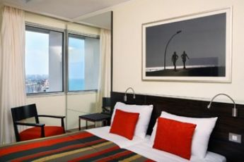

Tal Hotel **** - www.atlas.co.il

Tal hotel **** | Single room | Double room | Triple room
1 night | $ 165* | $ 175* | $ 245*
2 night | $ 330 | $ 350 | $ 490
3 night | $ 495 | $ 525 | $ 735
4 night | $ 660 | $ 700 | $ 980
* included breakfast

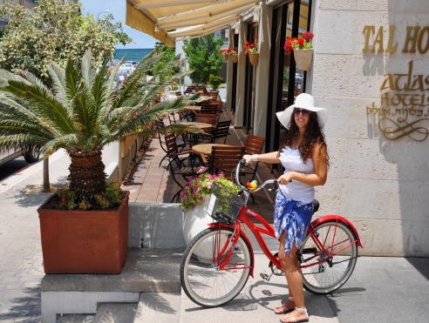

Tel-Aviv renovated port.

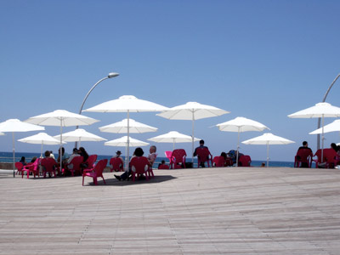

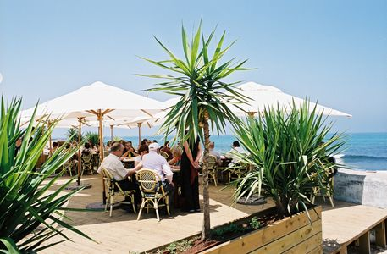



For more Information on Tel aviv renovated port: http://www.namal.co.il/en/default.aspx

Arrival at Ben Gurion Airport:
A pickup service for the participants from the airport to the hotel will be provided by courtesy of ITF Israel. Please let us know your arrival times and flight no, by November 15th 2012.

By Train:
Ben Gurion Airport line from Terminal 3 to Tel-Aviv Merkaz train station.
from Tel-Aviv Merkaz train station to the hotel: with a taxi or with bus line no. .55
to Hayarkon street and Yirmiyahu street.

Sports Hall – Goren-Goldstein Country Club – Tel-Aviv
7 Amikam St., Kiryat Shalom, Tel-Aviv

The Country Club is situated approximately 15 minutes drive south of
Tel-Aviv's main sea-side hotel area, near the old city of Jaffa.

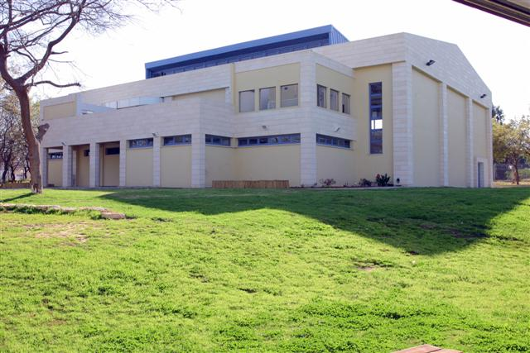

The Goren-Goldstein Country Club lies in a green and peaceful
corner of Tel-Aviv.

The Country Club is equipped with the most modern and
professional facilities.

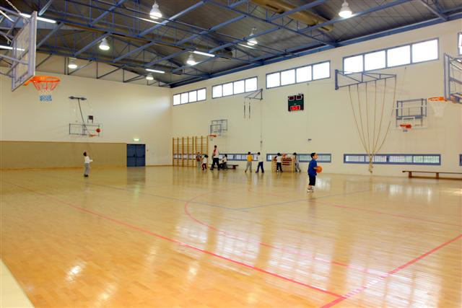

On location you can find a new sport's hall, fitness center, outdoor and indoor swimming pools, as well as a dry and wet sauna.

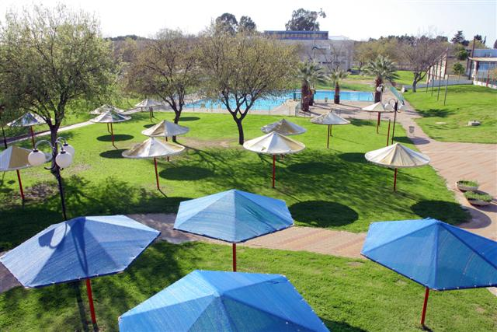

For those interested, a light meal will be served at the lunch break - for a fee.
A pickup service for the participants from the hotel to the sports hall will be provided by courtesy of ITF Israel.

Banquet Dinner.

We are excited to invites you to aspecial banquet dinner for our 10th anniversary, with the G.Masters team.
Getting together, jointly enjoying the atmosphere of a pleasant, enchanting, and special Shabbat eve.

The dinner will be served in the central dining hall,
Tal Hotel, 287 Hayarkon St., Tel-Aviv, on Friday, 30.11.2012, at 20:30.
$ 40.00 (per person)

Don't miss this unique and special event.
Come and enjoy the spirit of the holy land with the spirit of Taekwon-Do.

Yours in Taekwon-Do,

Danny Roth Leonardo Oros Duek
President I.T.A Secretary I.T.A

