

INTERNATIONAL T.K.D. FEDERATION
THE ISRAEL TAEKWON-DO ASSOCIATION

P.O.BOX 52- ZICHRON YA'AKOV -30900- TEL:+972-777002832
www.tkd-israel.org Email:leotufic@gmail.com

15.11.07

TO: All ITF Country Members.

Subject: International Instructors Course 2008 Israel.

Dear Madam/Sir,

The Israel Taekwon-do Association is honored to invite you to the International Instructors Course In Tel-Aviv, Israel .

Date: January 25 – 27, 2008

Venue: Sport hall Tel Aviv, Israel

The seminar will be conducted by the ITF Technical Committee:
Master Hector Marano (8th degree – Argentina).
Master Pablo Trajtenberg (8th degree – Argentina).
Master Willem Jacob Bos (8th degree – Italy).

Schedule:

Friday, January 25, 2008 08:00 – 12:00 Seminar
12:00 – 13:00 Lunch
13:00 – 15:00 Seminar
19:30 Banquet

Saturday, January (Shabbat) 26, 2008 08:30 Trip to Jerusalem

Sunday, January 27, 2008 08:30 - 12:00 Seminar
12:00 – 13:00 lunch
13:00 – 15:30 Seminar
16:00 – 18:00 Dan Grading

Day trip to Jerusalem: The Israel Taekwon-do Association invite all the participants from the world to visit the beautifull and holy city of Jerusalem - free of charge.

Course fees: 2 kup up to VI degree: $150 course fees +$50 registration.
VII degree and above: course fee waved; $50 registration.

Registration: (IIC Individual Inscription Form): at leotufic@gmail.com or
Fax: +972-77-7002832 before January 10th 2008.
Please indicate if you will be present at the banquet and the trip when applying for the course.

Accreditation and payment of the course fees: On Thursday 24 January 2008 at the Tal Hotel 17:00 – 18:00 (course fee, registration, and banquet).

Account: UNITED MARTIAL ARTISTS OF TAEKWON-DO ISRAEL
P.O.BOX 52 ZICRON YAAKOV 30900
Account:288092
IBAN:IL012625000000288092
SWIFT:POALILIT

Please make sure that for de identification of the participant the following information is provided with the payment:

Name of participant.
Name of the ITF Club.
Country.
IIC-2008.

Gradings on Sunday: Please send your application forms in advance (before December 30th ), as they have to be sent to the Grading Committee.

Promotion for Degree:

Promotion for Degree will take place on Sunday January 27th, 2008 at 16:00 hrs

Participants wishing to test for degree promotion must :

- send the application form through the National/Allied Association at least one (1) month before the promotion date to the ITF Administrative HQ.
- bring 5 wooden boards measured 30x30x2 cm (only from 1st to 6th degree).
- pay their ITF degree certificate and grading fee one hour prior to the grading.

See the appendix for more information on how to reach the hotel for accommodations.

Tel-Aviv's recently renovated port.

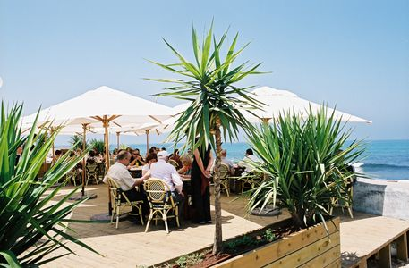

Hotel accommodation:
Tal Hotel , 287 Hayarkon Street, Tel aviv. Adjacent to the most legendary beach
in Tel -Aviv and close to the city's recently renovated port.

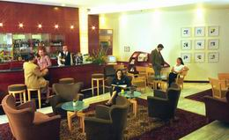

Tal Hotel **** - www.atlas.co.il

Tal hotel **** | Single room | Double room
1 night | $ 90* | $ 55 ( Price per person)*
2 night | $ 180 | $ 110
3 night | $ 270 | $ 165
4 night | $ 360 | $ 220
* included breakfast

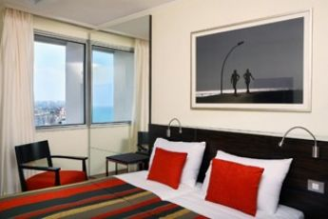

Arrival at Ben Gurion Airport:
A pickup service for the participants from the airport to the hotel will be provided by courtesy of ITF Israel. Please let us know your arrival times and flight no, by January 15th 2008.

By Train:
Ben Gurion Airport line from Terminal 3 to Tel-Aviv Merkaz train station.
from Tel-Aviv Merkaz train station to the hotel: with a taxi or with bus line no. .55
to Hayarkon street and Yirmiyahu street.

Sports Hall – Goren-Goldstein Country Club – Tel-Aviv
7 Amikam St., Kiryat Shalom, Tel-Aviv

The Country Club is situated approximately 15 minutes drive south of
Tel-Aviv's main sea-side hotel area, near the old city of Jaffa.

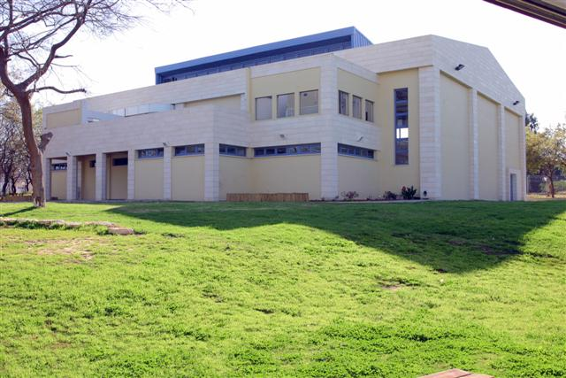

The Goren-Goldstein Country Club lies in a green and peaceful
corner of Tel-Aviv.

The Country Club is equipped with the most modern and
professional facilities.

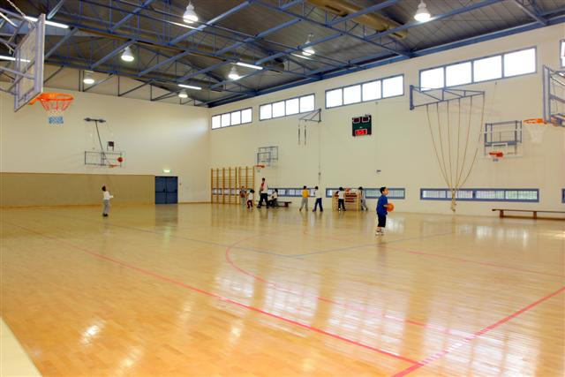

On location you can find a new sport's hall, fitness center, outdoor and indoor swimming pools, as well as a dry and wet sauna.

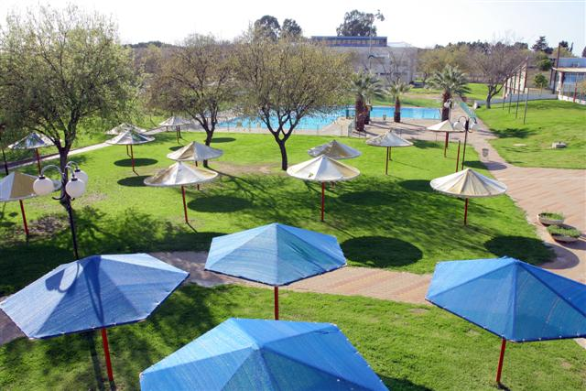

Course participants can enjoy free entry to the indoor pool and saunas during the course, after intensive training, subject to the Country Club's opening hours.
For those interested, a light meal will be served at the lunch break - for a fee.
A pickup service for the participants from the hotel to the sports hall will be provided by courtesy of ITF Israel.

Banquet Dinner.

You are hereby invited to a banquet dinner with the Masters team.
Getting together, talking and jointly enjoying the atmosphere of a pleasant, enchanting, and special Shabbat eve.

The dinner will be served in the central dining hall,
Tal Hotel, 287 Hayarkon St., Tel-Aviv, on Friday, 26.01.2008, at 19.30.

Menu:

10 Different kinds of salads: Tuna salad, Coleslaw, Tomato Salad, dressings and more.

Main course: Meat, Chicken and Fish.

3 Side dishes: Potatoas, pasta with variety of souses and baked vegetables.

3 Different kinds of desserts: hot chocolate cake, apple pie and fruits.

The dinner includes free wines and fruit juices.
Carbonated beverages will be charged extra.
$ 40.00 (per person)

Don't miss this unique and special event.

Please come in respectable, attire.

Come and enjoy the spirit of the holy land with the spirit of Taekwon-Do.

Yours in Taekwon-Do,

Danny Roth Leonardo Oros Duek
President I.T.A Secretary I.T.A
leotufic@gmail.com

