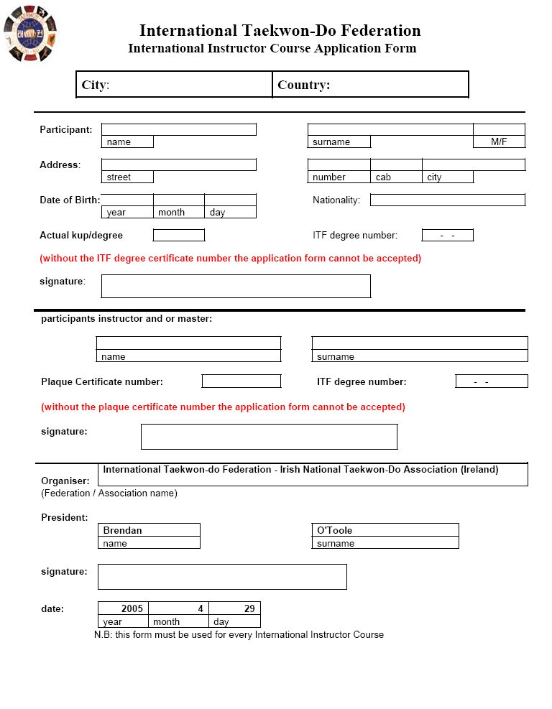
Marius
Oltean
2005
10
13-16
INTERNATIONAL TAEKWON-DO FEDERATION - ROMANIAN TAEKWON-DO FEDERATION ITF

