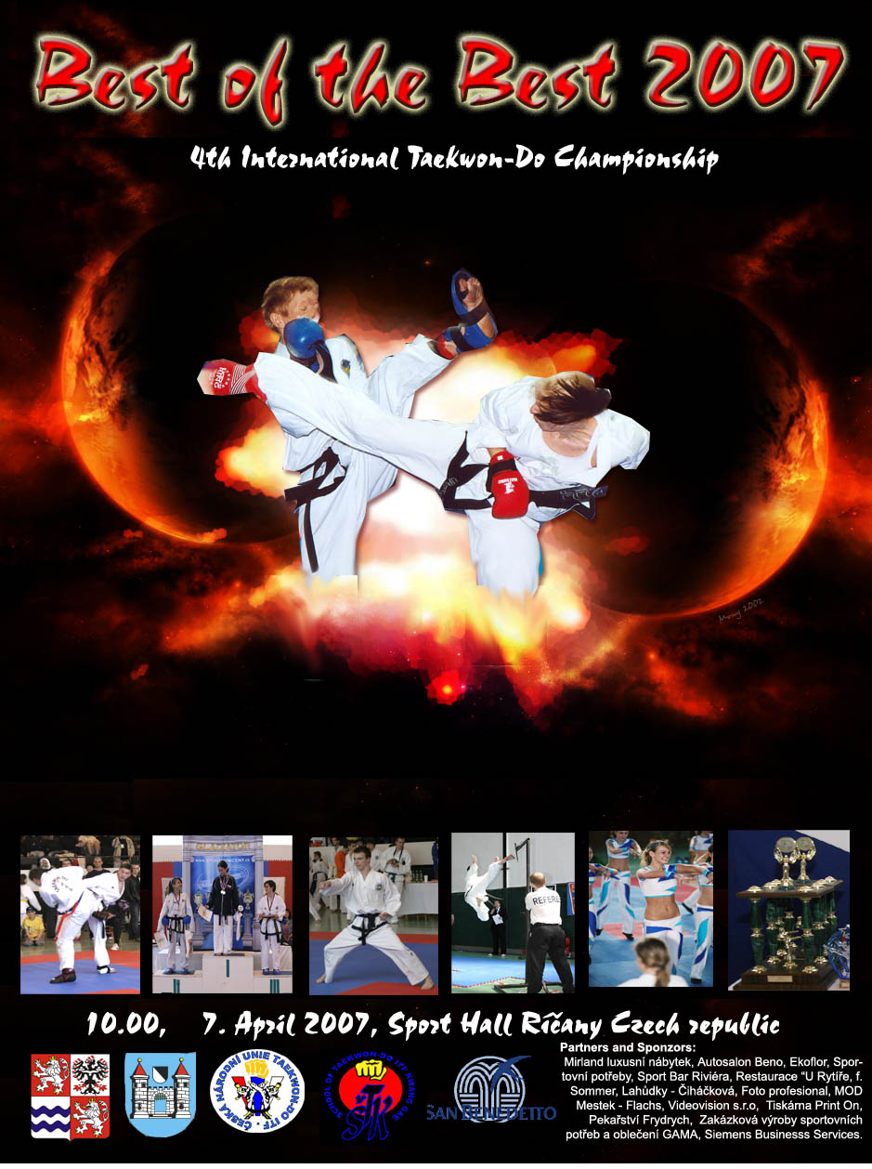

CNTU-ITF, Tehov–71, 251 01 Říčany Czech Republic, +420 728 408218, cz.itf@seznam.cz, www.taekwondounie.estranky.cz


www.championship.estranky.cz

Held on: April 7, 2007

Held at: SportHall in Říčany, located in a region Praha-východ ( Prague east )

Organizer: School of Taekwon-Do ITF Kwang Gae in cooperation with Czech National Union of Taekwon-Do ITF

Director
of the event: Mr. Viktor Stein

Head of referees:
Taekwon-Do: Mr. Vladimír Machota

Doctor: MUDr. Novotný

Fees: Registered members of ČNUT-ITF:
500,- CZK ( 20 Euro ) for both categories. 100,- CZK ( 4 Euro ) for each additional category. For categories, see “Registering for categories“.
Others:
550,- CZK ( 20 Euro ) for both categories. 100,- CZK ( 4 Euro ) for each additional category. For available categories, see “Registering for categories“

Registration at: from 8.00 am to 9.30 am

Opening ceremony: 10.00 am

Closing ceremony: 09.00 pm

www.championship.estranky.cz

Taekwon-Do Competition

Divisions: children, juniors, seniors

Tul

Boys from 8 to 15 years of age
( Minimal age limit must be reached at least at the day of the competition, maximal limit must not be exceeded up to the day of the competition)

9 - 8. grade, 7 - 5. grade, 4 - 3.grade, 2 grade to I. Degree

Girls from 8 to 15 years of age
( Minimal age limit must be reached at least at the day of the competition, maximal limit must not be exceeded up to the day of the competition)

9 - 8. grade, 7 - 5. grade, 4 - 3.grade, 2 grade to I. Degree

Junior male from 15 to 18 years of age
( Minimal age limit must be reached at least at the day of the competition, maximal limit must not be exceeded up to the day of the competition)

9 - 8. grade, 7 - 5. grade, 4 - 3.grade, 2 grade to I. Degree

Junior female from 15 to 18 years of age
( Minimal age limit must be reached at least at the day of the competition, maximal limit must not be exceeded up to the day of the competition)

9 - 8. grade, 7 - 5. grade, 4 - 3.grade, 2 grade to I. Degree

Male above 18 years of age
( Must be of the given age at the day of the competition)

9 - 8. grade, 7 - 4.grade, 3 – 1. grade, 1. grade and above
If there are more than six black belts present, special black belt only category will be opened

Female above 18 years of age
( Must be of the given age at the day of the competition)

9 - 8. grade, 7 - 4.grade, 3 – 1. grade, 1. grade and above
If there are more than six black belts present, special black belt only category will be opened

Matsogi

Boys from 8 to 15 years of age
( Minimal age limit must be reached at least at the day of the competition, maximal limit must not be exceeded up to the day of the competition)

Up to 140 cm, up to 150 cm, up to 160 cm, up to 170 cm, above 170 cm.

Girls from 8 to 15 years of age
( Minimal age limit must be reached at least at the day of the competition, maximal limit must not be exceeded up to the day of the competition)

Up to 140 cm, to 150 cm, to 160 cm, to 170 cm, above 170 cm.

Junior male from 15 to 18 years of age
( Minimal age limit must be reached at least at the day of the competition, maximal limit must not be exceeded up to the day of the competition)

Up to 52kg, to 58kg, to 63kg, to 70kg, above 70kg.

Junior female from 15 to 18 years of age
( Minimal age limit must be reached at least at the day of the competition, maximal limit must not be exceeded up to the day of the competition)

Up to 42kg, to 48kg, to 53kg, to 60kg, above 60kg.

Male above 18 years of age
( Must be of the given age at the day of the competition)

Up to 54kg, to 63kg, to 71kg, to 80kg, above 80kg.

Female above 18 years of age
( Must be of the given age at the day of the competition)

Up to 52kg, to 58kg, to 63kg, to 70kg, above 70kg.

Best of the Best Special Category of Matsogi, all weights
Best of the Best Special Category of Tul, all grades and degrees
Special Techniques Special Category of Breaking in the jump ( in accordance with ITF rules )
Model Sparring Male, Female, Both Male and Female, Children, Juniors, Seniors.

www.championship.estranky.cz

Registration for categories

The starting fee entitles the competitor to start in one category in fight and one category in forms. It is possible to start in additional categories, where the competitors meet the requirements. For each additional category 100 CZK is charged. If the competitor starts in two additional categories, the fee is reduced to 150 CZK.

Prices
Competitors placed at 1st, 2nd or one of the 3rd places will receive medal and diploma. The winner in junior and senior categories, where there are more than four competitors, receives a cup. The best competitor in each of children, junior and senior division will receive a cup. If there is more than one competitor with the same score in any respective division, no Best Competitor award is given out.

Scoring for the Czech National Taekwon-Do League

Best of the Best is an independent competition, where 1st to 3rd places are individually awarded.

The same scoring rules as in a regular League round apply. If a medal is received by a competitor from another martial art, the scoring for the League is done only according to the Taekwon-Do practitioners present in the category.

The scoring is as follows:
1st place - 4 points, 2nd place - 3 points, 3rd place - 2 points, 4th place - 1 point.

If a competitor starts in a second category in the same division, only the results from the base category are considered (the one where he would start by default)

Refrees
Every school has to ensure at least one qualified refree (see the Rules and Regulations of the Sport Committee). If the club cannot bring in a qualified refree, it must at least ensure one holder of 4th grade and above to be available for help to Organizing Committee (to help with result records, time-keeping and other services)
A small refreshment is prepared for all refrees. The Central and Corner refrees receive appropriate payment.

Safety equipment
Compulsory safety equipment is as follows:
Hand protection with covered fingers and opened palms, foot protection, gum shield, suspensor for male.

Optional safety equipment is as follows:
Shin protection, head protection, breast protection for female.

Sponsors
Sponsor logos must be placed in such a place where it does not obscure the ITF signs and must not be bigger than 70 cm square

Banners bigger than 1m square may be placed at the front facing wall and near the rings and doors only with agreement of Organizing Committee. Banners bigger than 10m square will be charged and accepted only by the Head of the Organizing Committee.
Meals
There is a small restaurant in the hall. In the close vicinity of the hall (up to 500 metres) a number of restaurants can be found.
Party
All participants is welcome to the banquet after competition ( small refreshment includet nonalkoholic drinks – for free ). The banquet will be held at saturday at 21.30 in Sport bar Riviera – Černokostelecká str. Říčany.
Applications
Please send the application by fax to the 323 60 30 64 or email to viktor.stein@seznam.cz, cz.itf@seznam.cz, or send SMS to 606 55 11 39.

!!!! Deadline is 08.00 pm, Friday, March 30, 2007 !!!!

Please fill in the name of the competitors, date of birth and weigth. The children should also state their height. Next fill in please their technical level, requested categories and if you apply for accommodation. The accommodation can be booked at Penzion Sedmikraska, in hotel Marta or in another pension not far from the hall. The accommodation basically differs by the level of services. For details please contact the Organizing Committee.
The Application form is enclosed.

Looking forward to seeing you
On behalf of the Organizing Committee
Vladimír Machota 5. Degree
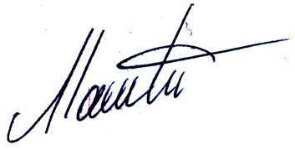

Competitors list

Taekwon-Do ITF Competition
School:

Surname – First name | Date of Birth | Matsogi  Weight | Tul  Tech. level | Height  (if child up to 15 years) | Best of the Best  Fight | Best of the Best  Forms
Muster Mustrovič | 9. 9. 1992 | 33,5 kg | 3 Kup | 164 cm | ANO | NE

Refree List

Surname – First name | School | Tech. level | Level of proficiency | Certificate number
www.championship.estranky.cz

Supporting team members list
School:
Coach: | VIP:
Coach: | VIP:
Coach: | VIP:
Doctor: | Other:

www.championship.estranky.cz

Accommodation and Meals

Accomodation numbers | Meals numbers
Friday to Saturday: / ubytovna: hotel:  Saturday to Sunday: / ubytovna: hotel:  Sunday to Monday: / ubytovna: hotel: | Friday: /breakfast: lunch: supper:  Saturday: /breakfast: lunch: supper:  Sunday: /breakfast: lunch: supper:
Accomodation: Hotel Marta cca 15 Euro Per person per night,
Pension Sedmikráska cca 17 Euro Per person per night.
Hotel Horizont cca 20 Euro per person per night.
Deadline is 08.00pm, Friday March 30, 2007

Please enter any message, comments or requests:

Sponsoring the International Taekwon-Do Championship Best of Best 2005:

Presentation of the company, its products or services in the scope of the competition.
1. Placing the company logo in the hall
- Logo up to 1 x 1 meter or equivalent area placed 150 centimeter behind the central refree table 700 CZK
- Logo bigger than 1 x 1 meter or equivalent area placed 150 centimeter behind the central refree table 1000 CZK
- Logo placed on the ring refree table up to 50x50 centimeter or equivalent area: 300 CZK for each table, 800 CZK for all four tables.
- Logo placed at the Primary Sponsor Panel, up to 50x50 centimeter or equivalent area: 700 CZK
- Logo placed at the Primary Sponsor Panel bigger than 50x50 centimeter but smaller than 1x1 meter or equivalent area: 1500 CZK
- Logo placed at the Primary Sponsor Panel bigger than 1x1 meter or equivalent area: 2000 CZK
- Logo located at the diploma, 150 pieces: 1500 CZK
- Logo placed at all document and materials used by ČNUT: 1000 CZK
2. Placing a presentation standpoint
- In the hall during the competition away from the rings: 3000 CZK
- In the hall during the competition: 3500 CZK
3. Placing of the propagation materials (leaflets, banners, business cards, etc.)
- In the hall away from the rings during the competition: 300 CZK
- In the hall during the competition: 500 CZK
4. Presentation of the company, services or products at the Opening, Awarding or Closing Ceremony: 1500 CZK
5. Presentation of the company at the ČNUT website for one year: 5000 CZK
6. Presenting the firm, services or products as the General Sponsor of the International Taekwon-Do Championship Best of Best 2005. Price for Exclusive Sponsorship (eg. No other sponsor is permitted): 50 000 CZK. This type of sponsorship gives the sponsor the right to receive complete revenue of the Competition, after deducing the expenses for refrees and Organizing Committee. Also the company becomes eligible for a priority partneship with the Czech National Team.
7. Naming the International Taekwon-Do Championship Best of Best 2005 with the company, service or product name.
- This year`s championship : 90 000 CZK
- If a contract for this year`s and next year is signed, discounted price make 100 000 CZK for both.

Further services of Czech National Union of Taekwon-Do ITF
- Placing the logo, link or banner to the website of ČNUT (more than 7000 visitors in three months).
- Placing the logo or advertisement on the sport suit, dobok (a competition suit), bag or t-shirt..
- Placing the logo on an official documents template of ČNUT
- Contract with the National Team on advertisment and exhibitions.
- Presenting the company, services or products through the National Team
- Estate and all other security services.
- Introducing the company into business relationship with foreign teams and associations.
- Introducing the company representative or partner into the International Taekwon-Do Federation

All of the above mentioned services can be combined based on mutual agreement. Further agreements concerning the Czech National League is possible.
For further information and cooperation contact Czech National Union of Taekwon-Do ITF at or +420 728 40 82 18 ( Cze, Cro, Eng, Deu, Rus language ) +420 606 55 11 39 only in Czech.
Contact person is Vladimír Machota or Mr. Viktor Stein

