Tampere, 3.01.2007

To the Board of the All Europe Taekwon-Do Federation

Subject:
Motion concerning organizing the 2nd European Taekwon-Do Cup in Tampere, Finland

Hereby, I present second motion concerning hosting the 2nd European Cup in Tampere, Finland as initially agreed during the AETF congress in Italy, 2005.

Please find listed below details concerning the organizing matters.

Organizing Committee:

ITF Taekwon-Do Finland and Tampere Taekwon-Do Club will take responsibility of hosting this event.
The executive board of the organizing committee consists of:
1. Mariusz Steckiewicz (ITF Finland president), Chairman of the organizing committee, +358405381020, Office address: Vasaratie 20 B 17, 33710 Tampere, Finland, mariusz@taekwondo.com.pl
2. Jori Aaltonen (Tampere TKD Club president, ITF Finland board member), EuroCup venue director
3. Anssi Hähärä (ITF Finland vice-president), EuroCup graphic designer
4. Teppo Häyrynen (ITF Finland Umpire Director),
5. Ari Asplund, EuroCup treasurer,
6. Lasse Kuusisto, EuroCup IT director,
7. Heli Karjalainen (ITF Taekwon-Do Finland Board member),

Date and place:
October 5-7, 2007, Tampere, Finland

Venue:
MetroAuto Areena
Jäähallinraitti 3
33540 Tampere
http://www.metroautoareena.fi
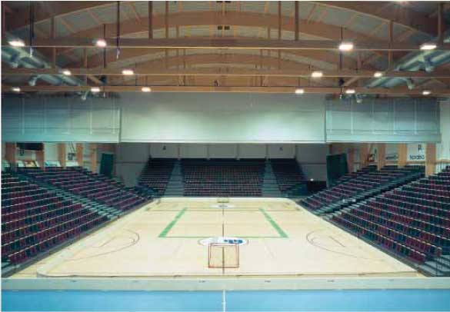

Metro-Auto Areena is a modern multi sport hall. It can easily fit full 3-4 rings with fully opened spectator’s area. Closing spectator’s area can significantly increase the competition space. Full capacity of the spectator’s area amounts for 3000 sitting places.
The venue is well equipped with the sufficient changing rooms, meeting/conference rooms, dining place and leisure space (bowling, pool).
Metro-Auto Areena is located 2.5 km from the centre of Tampere with a convenient bus access.
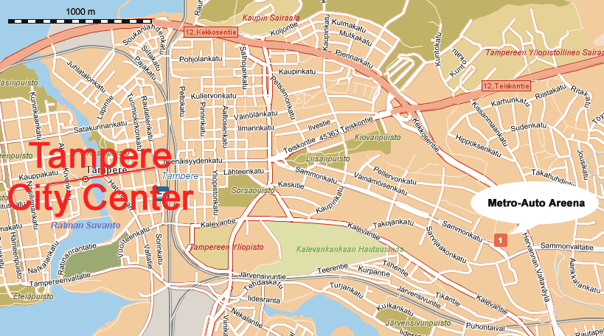

Accommodation:
Participants will be offered 2 accommodation packages.
A: 3 star hotel with the price of 40 € /person in a double room with the possibility of adding one extra bed free of charge. Price includes bed and breakfast.
B: Hostel with the price of 20 € /person without breakfast (or 26 € with breakfast).
Both accommodation options are situated with the distance of 2.5-4 km from the competition place. Option A hotel is located in the very centre of Tampere. The hostel is located with the walking distance from the main shopping street of Tampere.

Participants will be also offered possibility of buying warm lunch at the competition place with the price of 5€.

Transportation:
Organizer will provide free transportation hotel/hostel <> competition venue.
Participants will be offered low cost transportation from/to the Pirkkala Airport.

Arrival possibilities:
Tampere can be reached by car, train, bus and plane.
Train and bus connections are available from all main communication junctions in Finland: Helsinki (180km), Turku (Åbo) (150km), Vaasa (200km), Oulu (450km), St. Petersburg (600km).
Pirkkala Airport located 15km from the Tampere centre enables direct connections from most of the European countries including direct budget connections from UK, Sweden, Germany, Ireland and Latvia.
Finland can be also reached by ferry from Estonia, Russia, Latvia, Sweden and Germany.

Financial assurance:

European Cup will be financed mainly from the participation fee (50% of the entry fee), sponsors, entry tickets and sale of the various goods (like: T-shirts, gadgets, sport equipment).

Motion substantiation:

Organizing committee is fully aware of the scale of the project, scope of work and sure of its capability to organize and manage European Cup in October 2007. Organizing committee members are professionals in their range of responsibilities and experienced in similar activities.
Previous experiences in organizing various tournaments: National Championships, Nordic Championships, international seminars and European Championships 2004 gives us necessary knowledge and confidence.
Very good co-operation with the Tampere city authorities’ guarantees easier access to the sport facilities and equipment as well as promotional and advertising media.
We are currently working on wide promotional package to draw attention of serious potential sponsors, newspapers and TV media.

Tampere is worldwide well known city for its sports and exhibitions hosting traditions.
Located in southern Finland, Tampere at this time of the year assures still quite good weather conditions with the temperature about 15-20 degrees. Visiting Finland guarantees experiencing unshaken nature, clean lakes and interesting culture.

With this letter I would like to express my hope that AETF Board will accept Tampere as the host of the next European Cup 2007.

With kind regards,



Mariusz Steckiewicz
Chairman of the Organizing Committee

