NOVEMBER 18-20 ,2011

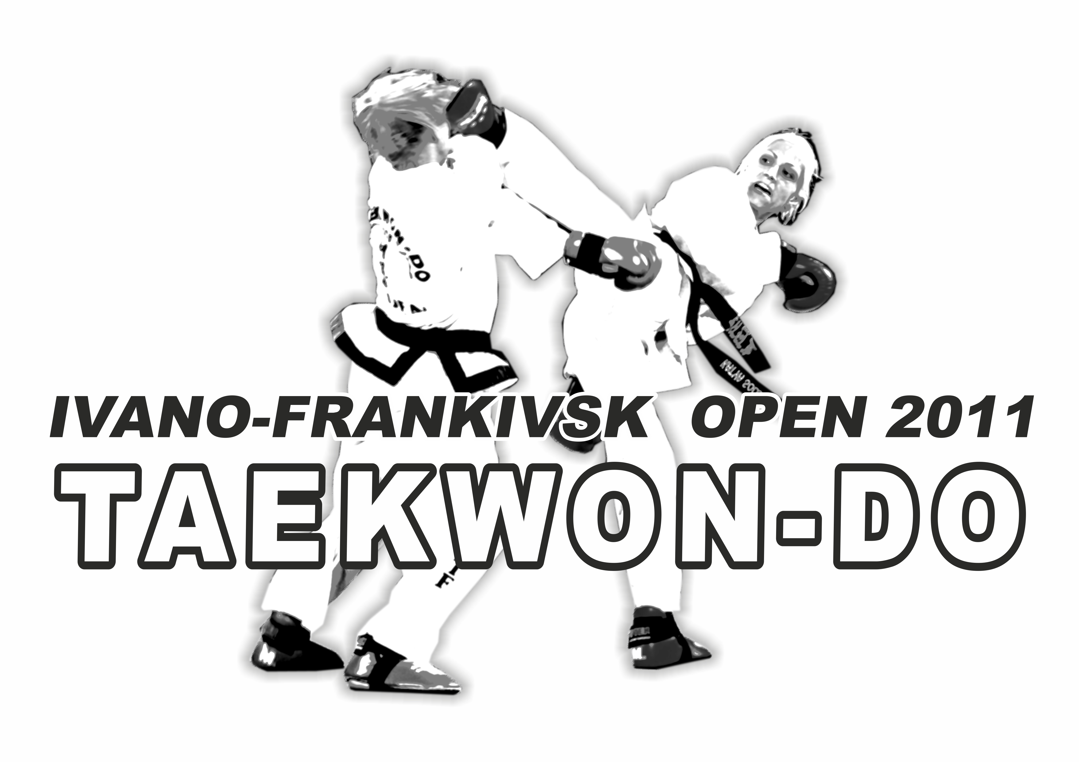

Ivano-Frankivs,Ukraine

ALL UKRAINIAN TAEKWON-DO UNION

Ivano-Frankivsk open

November 18-20 2011
Willy van de Mortel e-mail: willy.vandemortel@wxs.nl
Harry van Schaik e-mail: info@promatour.com
Master James Tjin-A-Ton e-mail: info@itf-taekwondo.nl

Date:
November 18-20 2011

Place:
Sports hall, Ivano-Frankivsk College of Physical Education
76025,Getmana Mazepy str.142 a,Ivano-Frankivsk,Ukraine.

Time table:

Friday, 18th November, 2011
- 08:30 – 17.00 Arrival of the teams at meeting point the College of Physical Education, Registration and Weighing – In College of Physical Education
- 17.00 – 18.30 Umpires meeting - College of Physical Education
- 18.30 – 19.30 Coaches Meeting - College of Physical Education

Saturday, 19th November, 2011
- 09.00 – 13.00 Competition(individual sparring)
- 13.00 – 13.45 Opening ceremony
- 14.00 – 18.00 Competition
- 18.00 – 19.00 Medal awarding

Sunday, 20th November, 2011
- 08.30 – 16.00 Competition (team sparring)
- 16.00 – 16.30 Medal awarding

Events and categories::
- individual sparring (I.T.F-Taekwon-Do rules);
Team sparring: (kids/Cadets/junior/senior)

Sparring Time:
Kids: 2 x 1,5 minutes
Kadets 2 x 1,5 minutes
Juniors/Seniors: 2 x 2 minutes
(The organizer has the right to change the time)

Ivano-Frankivsk open

November 19-20 2011

Divisions and classes:
There are divisions and classes for kids, cadets, juniors and seniors
They are divided in grading, weights;
Every event we use the knock-out system
Male/Female Kids/cadets/Juniors/Seniors are divided in separate classes.

Ages:
Kids Female: 9-11 year.
Kids Male: 9-11 year.
Cadets Female 12-14 year.
Cadets Female 12-14 year.
Juniors Female: 15 - 17 year.
Juniors Male: 15 - 17 year.
Seniors Female: 18 +
Seniors Male: 18 +

Classes Sparring:
A division: blue belt and higher
B class: white belt up to green belt
1. All competitors must have full insurance cover.
2. Boxing or open gloves are not allowed, short shin protectors are allowed.

Weight categories Sparring:
Kids Female 9-11 year: -25, -30, -35, -40, -45, +45 kg.
Kids Male 9-11 year: -25, -30, -35, -40, -45, +45 kg.

Cadets Female 12-14 year: -35, -40, -45, -50, -55, +55 kg
Cadets Male 12-14 year: -35, -40, -45, -50, -55, +55 kg

Juniors Female 15-17 year: -45, -50, -55, -60, +60kg
Juniors Male 15-17 year: -52, -58, -63, -70, +70 kg

Seniors Female +18 year: -55, -60, -65,+65 kg
Seniors Male +18 year: -54, -63, -71, -80, +80 kg

2th Ivano-Frankivsk open

November 19-20 2011

Umpires: Must wear, blue/black trousers, white shirt long sleeves, blue/black tie.
Every club/team must bring umpires. If no umpire is submitted there will be a fine of €.50,- for every missing umpire.
Up to 7 competitors 1 Umpire
8 up to 15 Competitors 2 Umpires
16 competitors ore more 3 Umpires

Coaches:
2 coach 1 up to 7 competitors
3 coaches 8 up to 14 competitors
4 coaches 15 up to 20 competitors
5 coaches 20 competitors or more

Rules:
- 1 point for all hand techniques head/chest;
- 2 points for all kicks to the chest;
- 3 points for all kicks to the head.

Points, warnings, minus points and disqualification are recording
I.T.F. - AETF Taekwon-Do rules,
http://www.tkd-itf.home.pl/pub/ver_eng/comp_rules.html or
http://www.itfeurope.org/competition_rules.html
In case of a dispute the Head referee have the final decision.

Fees competition:

Individual sparring 15.00 Euro
Team sparring 20.00 Euro for team

Ivano-Frankivsk open

November 19-20 2011

Entry forms send to:

Oleg Solovey
Or to itf-ukraine@mail.ru

The deadline for the entry form is November 9th 2011!!

Hotel accommodation:
We can offer different and very good accommodation.
Please inform us as soon as possible how many persons will arrive.
The bus transportation to the sport hall

Top event for competitors, coaches, referees and supporters:
The tournament directors can assure you that this event will satisfied your desire to compete in a professional environment. You and your athletes deserve this!!

Tournament Directors:
Oleg Solovey V degree ITF,
Oleg Petrovskiy VII degree ITF

Contact:
Oleg Solovey
Tel/Fax: +380342717848
Mobile: +380504388777
E-mail: itf-ukraine@mail.ru
Web : www.taekwon-do.com.ua

