The 1st European Cup
21st-24th October 2005
Crawley, England
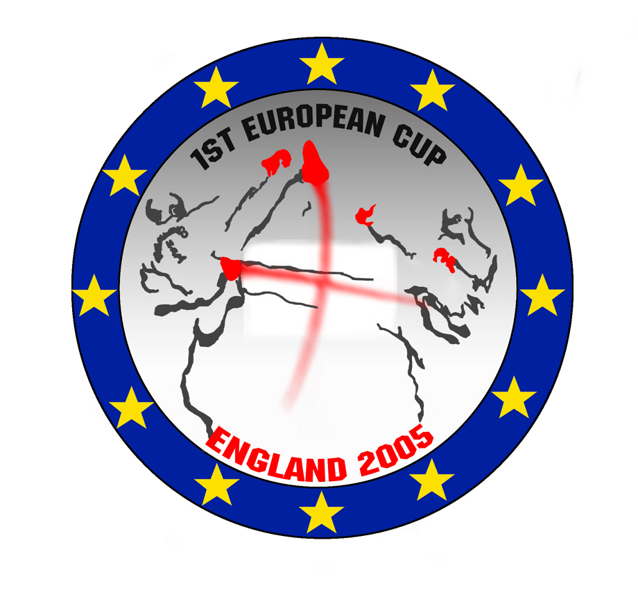




TAEKWON-DO IMPACT
43 Guildersfield Road, Streatham
London SW16 5LS
Web: www.tkdimpact.com Email: info@tkdimpact.com
Tel: +44 208 6790526 Fax: + 44 208 4807448

16th June 2005

Dear Masters and Instructors,

RE: 1st EUROPEAN CUP 2005

It is with great pleasure that you and your students are invited to the 1st European Cup on the 21st-24th October in Crawley, West Sussex. With our proven track record we are committed to providing a well run and exciting competition for the competitors and spectators. The competition is open to blue belts and above for ages 16-45 years (competitors must be born in the year 1989 or earlier).

Please take the time to read the following information. If you have any queries please do not hesitate to contact us at the above address.

We look forward to meeting you at the competition.

Yours in Taekwon-Do,

Philip Lear
Tournaments Director
1.0 Venue, Dates and accommodation

1.1 Dates
The competition will be held on Saturday 22nd and Sunday 23rd October. All competitors must register and weigh in on Friday 21st at the Gatwick Europa Hotel from 11am-11pm. Countries will depart on Monday 24th October.

1.2 Venue
The competition will be held at Crawley Leisure Centre , Haslett Avenue, Crawley, West Sussex, which is 5 miles from Gatwick Airport.
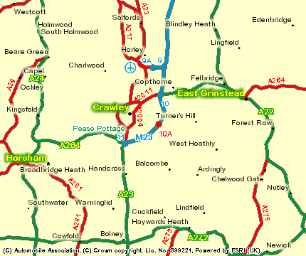

1.3 Travel Directions
To the Sports Centre.
From M23 take exit junction 10. Take the ring road A2011 and then the 1st exit at 1st roundabout. Follow signs to Hawth Theatre. At the next roundabout take the 2nd exit, then turn right at traffic lights. Continue until you reach the squareabout where you will see a Holiday Inn Express on straight ahead. Haslett Avenue and the Sports Centre will be on your left at the first exit.

Impact will provide a shuttle service for competitors and umpires between the hotel and the sports centre. Please contact the Impact Office at info@tkdimpact.com to arrange transport from the Airport and the return.

1.4 Accommodation
The Hotel is Gatwick Europa Hotel, Balcombe Road, Maidenbower, Crawley, Gatwick, West Sussex, RH10 7ZR. Please book the number of rooms required and whether a single, twin or triple room. The rate includes a buffet breakfast and 3 course dinner. Please see the attached details concerning the hotel and complete the form available on the website www.tkdimpact.com when registering the competitors. The hotel must be paid in advance either by credit card online or by bank transfer. For every 12 competitors the hotel will be free of charge for one referee with shared accommodation only from 21st-24th October.

2.0 Rules and requirements

2.1 Rules
The competition will be run in accordance with the AETF competition rules, except where specified otherwise in this invitation.

2.2 Competitor Requirements
Competitors must of blue belt grade or higher and be aged between 16 and 45 years. The minimum age of 16 years must be attained by the competitor during the year 2005 (minimum year of birth 1989).

Only clubs and schools, that have a valid ITF plaque certificate, and/or national teams, representing countries that have paid the annual fee to the AETF, may take part in the European Cup.

2.3 Referee Requirements
All clubs or schools with more than 3 competitors taking parts in EC must bring at least 1 referee: where a referee is not provided the club/school will incur a charge (see 3.4). All clubs and schools with less than 4 competitors taking part in the competition may bring a referee but are not required to do so.

2.4 Protection Equipment Requirements
As per the AETF safety guidelines. All competitors must wear the approved TOP TEN Sparring equipment for this competition. No other equipment can be used, therefore there will be some TOP TEN gloves and feet pads available for use.

3.0 FEES

3.1 Competitor Fees
Individual entry fees are €70 Euros.
Team events are €30 Euros per team.
No refunds will be given for any reason even if a competitor is disqualified.

3.2 Spectator Fees
The cost for spectator fees are £5.00 (7 Euros 50) for one day or £7.50 (11 Euros 50) for two days.

3.3 Coach
One Coach per 12 competitors will be allowed free entry to the competition. Their name must be submitted with the entry form online.

3.4 Referee Fees
Where a referee cannot be provided, as detailed in 2.3, then a charge of €250 Euros will be incurred.
4.0 INSTRUCTIONS AND DEADLINE

Please distribute the competitor forms, included in this invite, to your students which they should complete and sign. Use these to complete the forms online at www.tkdimpact.com. Please ensure that the forms are filled out correctly, as mistakes will incur a further charge or result in disqualification. All UK clubs must pay online using a credit card. Clubs travelling from the EU may either pay online or on arrival at the Gatwick Europa Hotel.

If a referee is not provided then the referee charge must be added to the payment (see sections 2.3 and 3.4).

The closing date for this competition is Friday 23rd September please note that no entries will be accepted after this date.

5.0 ALTERATIONS

5.1 Entry Alterations
Please note that alterations to entries made after the closing date will incur a charge of £10 (15 Euros). Once a competitor has entered an event(s) no refunds will be given if the competitor decides to withdraw from an event(s).

5.2 Weigh-In
At registration on Friday 21st October, if any competitor has not made their weight they will be disqualified from that event.

6.0 DISPUTES
The referee’s decision is final.

7.0 EVENTS AND CATEGORIES
The hosts reserve the right to amalgamate/change events on the day of the competition.

7.1 Individual Sparring
All sparring bouts will be two rounds of two minutes
All events will be separated in to Male and Female.

Blue and Red Belts will compete together separated into the 5 weight categories below.

Black Belts will compete together separated into the 5 weight categories below.

The categories are:

Category | Male Black Belt | Female Black Belt | Male Blue/Red Belt | Female Blue/Red Belt
Micro | -54Kgs | -52Kgs | -54Kgs | -52Kgs
Light | -63Kgs | -58Kgs | -63Kgs | -58Kgs
Middle | -71Kgs | -63Kgs | -71Kgs | -63Kgs
Heavy | -80Kgs | -70Kgs | -80Kgs | -70Kgs
Hyper | +80 kg | +70Kgs | +80 kg | +70Kgs

7.2 Individual Patterns
In all bouts the competitors will perform an optional and designated pattern.

Blue and Red Belts will compete together separated in to Male and Female.

Black Belts will be separated by grade i.e. 4 categories from 1st to 6th Degree (4th, 5th & 6th Degree together) and further subdivided in to Male and Female.

7.3 Team Sparring
Teams can consist of 6 members but with a minimum of 5 for male and 3 for female. This is a black belt event but blue and red belts can also take part in this event. All bouts will be one round of two minutes.

8.0 ENTRY FORMS

8.1 Individual Form

21st-23rd Oct 2005 | TAEKWON-DO IMPACT EUROPEAN CUP 2005  ENTRY FORM
First name Surname

TKD School/Club Country

Gender  Male Female |  | Date of Birth (dd/mm/yy)
   |  | / |  |  | /
Grade  Blue/Red Belt  1st Degree  2nd Degree  3rd Degree  4th-6th Degree |  | Events entered  Patterns  Sparring  Team Sparring | Sparring categories  Please tick weight category below if entered for individual sparring  Male Female  Micro (–54kg) Micro (–52kg)  Light (–63kg) Light (–58kg)  Middle (–71kg) Middle (–63kg)  Heavy (–80kg) Heavy (–70kg)  Hyper (+80kg) Hyper (+70kg)
DISCLAIMER:

Please note that this is an adult competition and each competitor must be able to cope with this level. Taekwon-Do Impact recommends that all under 18’s should prepare themselves physically for this adult competition and also wear full safety equipment including shin guards, mouth guard and head guard.

Whilst Taekwon-Do Impact Ltd will ensure a high standard of safety in its championships, by signing this form you acknowledge that you have appropriate insurance, that there is an element of risk and that you could still sustain an injury. Knowing this you accept these conditions and voluntarily agree to assume this risk.

Signature________________________________ (Parent/Guardians Signature for under 18yrs)

21st-23rd Oct 2005 |  | TAEKWON-DO IMPACT EUROPEAN CUP 2005  TEAM SPARRING ENTRY FORM
Team Name |  |  | Gender  Male Female
TKD School/Club Country

 | First name Surname
1
2
3
4
5
6
8.2 Team Entry Form

Gatwick Europa Hotel

Address: Balcombe Road, Maidenbower, Crawley, Gatwick, West Sussex, RH10 7ZR



- Europa Gatwick Hotel, Accommodation -

Guest Bedrooms at the Britannia Europa Gatwick Airport Hotel:
There are 211 guest bedrooms at the Europa Gatwick Airport Hotel, and all are ensuite. They are also very comfortable and tastefully decorated, and have the following facilities available:
- Complimentary tray
- Colour television
- Hairdryer
- Trouser press
- Direct dial telephones

The Europa Gatwick Airport Hotel is beautifully designed and decorated, and has quite a unique appearance given it's low rise hacienda style building. It is centred around a beautiful garden which has an impressive water feature. The ceilings are very attractive as they are exposed timber, and this combined with the terrazzo and marble features public areas create a warm and welcoming Mediterranean feel.

Health Suite Facilities
- Sun bed
- Sauna
- Steam Room
- Jacuzzi

Swimming Facilities
- Swimming Pool

Fitness Centre / Gym Facilities
- Croquet and Golf

COST:
£30 (45 Euros) per room per night (Twin)
£27 (40 Euros) per room per night (Triple)
Add an extra £10 (15 Euros) for a single
This includes Buffet Breakfast and 3 course Dinner, (Drinks not included.)

BOOKING MUST BE COMPLETED WITH THE ENTRIES BY 23rd SEPTEMBER
HOTEL BOOKING FORM

CLUB:…………………………………….... COUNTRY:…………………………………………

PERSON RESPONSIBLE FOR THE BOOKING:………………………………………………….

EMAIL:………………………………… TEL NO:……………………………………………..

WE REQUIRE: Single Rooms - @ £40 (60 Euros) Per room

Twin Rooms - @ £60 (90 Euros) Per room

Triple Rooms - @ £81 (120 Euros) Per room

TOTAL IN GBP £…………..

PLEASE TICK

Arrival 21st October - Departure 24th October

Arrival 21st October – Departure 23rd October

For every 12 competitors the hotel will be free of charge for one referee with shared accommodation only from 21st-24th October. please complete the referee booking form below:

More than 12 competitors:

Referees Name:………………………………………………….. Degree:………........

More than 24 competitors

Referees Name:………………………………………………….. Degree:………........

More than 36 competitors

Referees Name:………………………………………………….. Degree:………........

