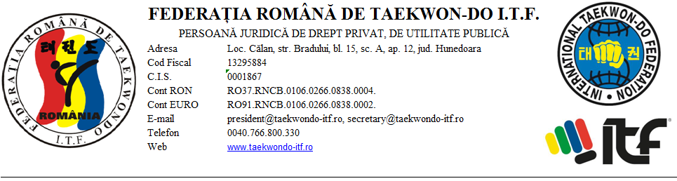

INVITATION

Romanian Taekwon-do I.T.F. Federation and Tae-Kyon Oradea Sports Club have the pleasure and honor to invite you to participate at the first edition of the “INTERNATIONAL GEN. CHOI MEMORIAL CUP,, for Juniors III, II, I and seniors held between 18-21 June 2015 in Oradea, Bihor County, Romania.

The Organizing Committee works hard to give you the best contest conditions and it is eagerly looking forward to welcome a greater number of athletes at the premiere sporting event in Romania.

Yours sincerely,

President,
Cosmin Oprescu

”INTERNATIONAL GENERAL CHOI MEMORIAL CUP”
JUNIOR III, JUNIOR II, JUNIOR I and SENIOR,
18 - 21 June 2015, Oradea

A. GENERAL INFORMATION

1. CO-SPONSORS

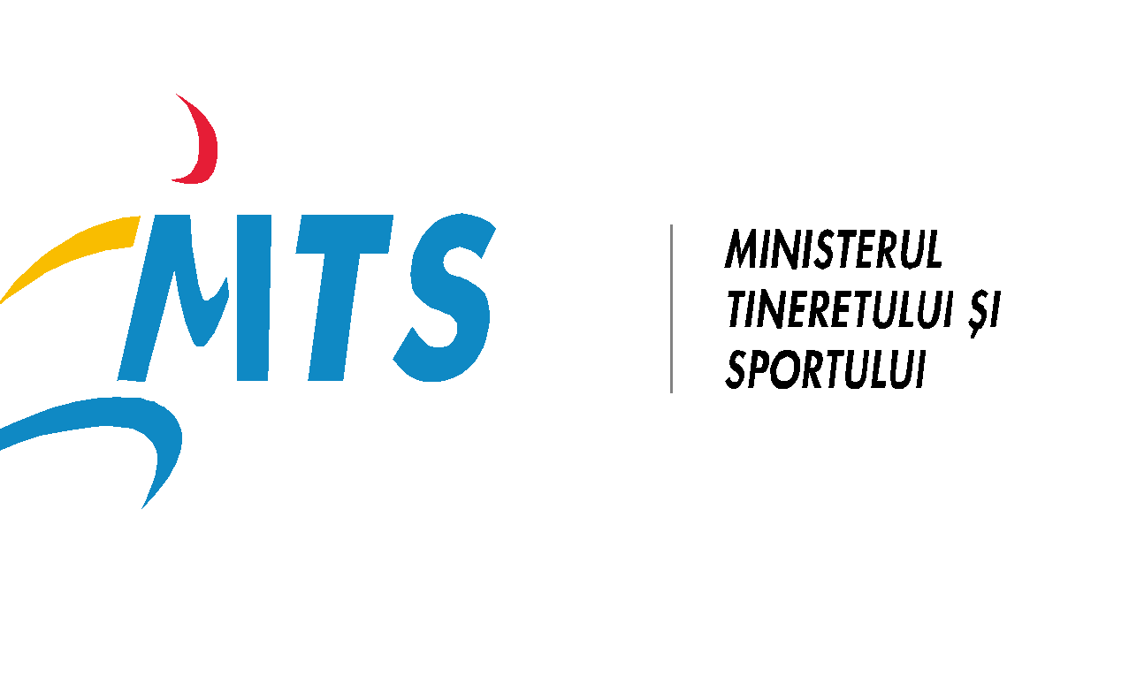 | The Ministry of Youth and Sports  www.mts.gov.ro

2. ORGANIZER
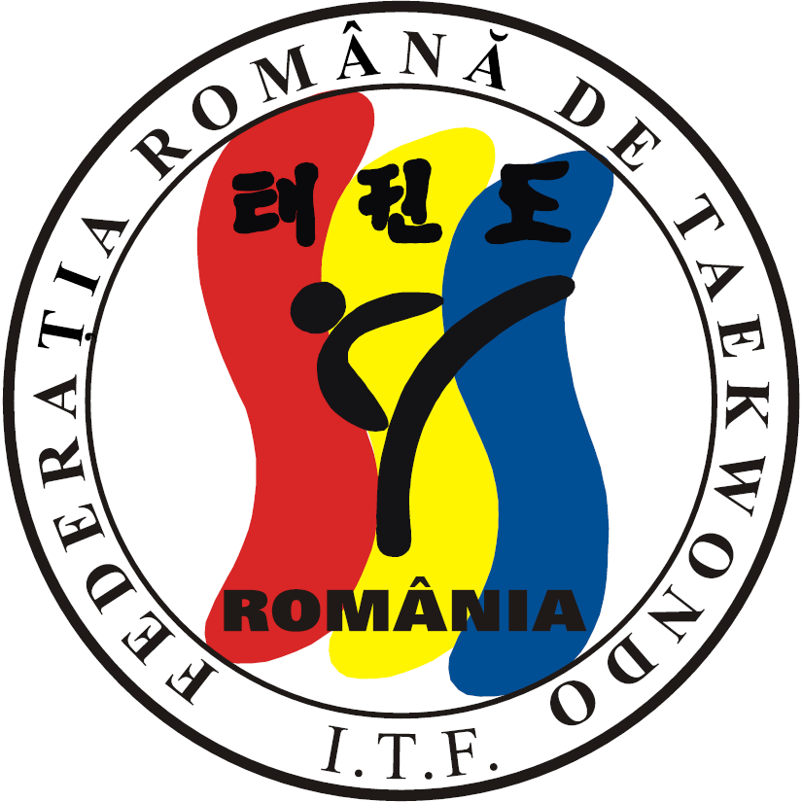  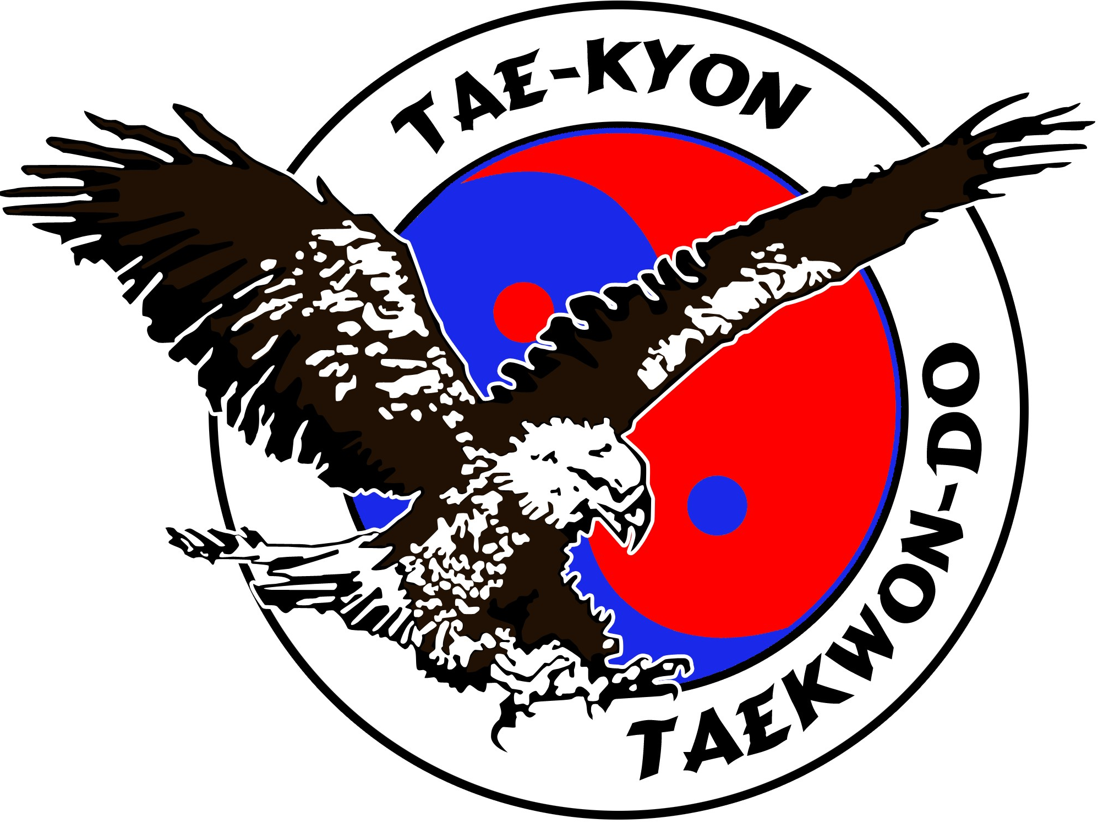 | Romanian Taekwon-do I.T.F Federation.  Bradului str., 15-A-12  Călan, Hunedoara County  Tel: 0766.800.330  Email: president@taekwondo-itf.ro  The TAE-KYON Oradea Sports Club  Salcâmilor str., no.11, bl. PB 147, ap. 18  Oradea, Bihor County  Tel. 0744 538 239, 0770 815 705  Email: taekyon_ro@yahoo.com, alexandru_sas74@yahoo.com
3. DATE 18-21 June 2015

4. PLACE The Sports Hall of the University of Oradea
Făgărașului str., Oradea, Bihor County

B. RULES

- PARTICIPANTS
The Sport Structures with C.I.S. issued by M.Y.S., affiliated to the Romanian Taekwon-do I.T.F. Federation, A.E.T.F. or International Taekwon-do Federation.
Unlimited number of athletes / category / club can participate.
The minimum Grade admitted:
- Junior III, II, I and Senior: 8 GUP (yellow belt)

2. COMPETITION SECTIONS

JUNIOR III and JUNIOR II:
- Individual Pattern (male and female): -6 years; -8 years; -10 years; -12 years; -14 years;
- Team Pattern (M/F);
- Individual Sparring (male and female): -6 years; -8 years;
- Individual Sparring (8-10 years) Male: -32 kg; -40 kg; +40 kg;
Female: -30 kg; -35 kg; +35 kg;
- Individual Sparring (10-12 years) Male: -35 kg; -45 kg; -55 kg; +55 kg;
Female: -36 kg; -45 kg; +45 kg;
- Individual Sparring (12 -14 years) Male/Female: -42 kg; -50 kg; -58 kg; +58 kg;
- Special Technics:
- 10 years ( two groups in height)
1. Twimyo nopi yop cha jirugi
- 10 -12 years (two groups in height)
1. Twimyo nopi yop cha jirugi
2. Twimyo nopi ap cha jirugi
- 12 -14 years (two groups in height)
1. Twimyo nopi yop cha jirugi
2. Twimyo nopi ap cha jirugi

JUNIORS I (can participate junior 14 years turned and 18 years not yet turned until 18 June 2015):
  - Individual Pattern male and female: colored belts, I DAN, II DAN;
  - Team Pattern male and female (minimum 5 juniors);
(The number of imposed patterns will be fixed at the technical meeting, regarding the registered number of sportsmen at this), team pattern, male and female)
  - Male Individual Sparring: -50 kg; -56 kg; -62 kg; -68 kg; -75 kg; + 75 kg;
  - Female Individual Sparring: -45 kg; -50 kg; -55 kg; -60 kg; -65 kg; + 65 kg;
  - Male and female Team Sparring (minimum 3 juniors);
  - Individual Power breaking male and female;
  - Team Power breaking (minimum 3 juniors);
  - Individual Special Technics male and female;
  - Team Special Technics male and female (minimum 3 juniors);
  - Sparring: the team can be mixt: male - female, just juniors ( Separate tax for this is not charged)

SENIORS (pot participate just senior sportsmen):
  - Individual Pattern male and female: colored belts, I DAN, II DAN, III DAN, IV – V DAN
  - Team Pattern male and female (minimum 5 seniors);
(The number of imposed patterns will be fixed at the technical meeting, regarding the registered number of sportsmen at this), team pattern, male and female)
  - Male Individual Sparring: -57 kg; -63 kg; -70 kg; -78 kg; -85 kg; +85 kg;
  - Female Individual Sparring: -50 kg; -56 kg; -62 kg; -68 kg; -75 kg; +75 kg;
  - Male and female Team Sparring (minimum 3 seniors);
  - Individual Power breaking male and female;
  - Team Power breaking (minim 3 seniors);
  - Individual Special Technics male and female;
  - Team Special Technics male and female (minim 3 seniors);
  - Sparring: the team can be mixt: male – female ( Separate tax for this is not charged)

MALE SPECIAL TECHNICS
 | JUNIOR | SENIOR
TWIMYO NOPI AP CHA BUSIGI | 250 cm | 260 cm
TWIMYO DOLLYO CHAGI | 230 cm | 240 cm
TWIMYO BANDAE DOLLYO CHAGI | 210 cm | 220 cm
TWIMYO DOLMYO YOP CHA JIRUGI | 210 cm | 220 cm
TWIMYO NOPI YOP CHA JIRUGI | 130 cm | 140 cm

FEMALE SPECIAL TECHNICS
 | JUNIOR | SENIOR
TWIMYO NOPI AP CHA BUSIGI | 210 cm | 220 cm
TWIMYO DOLLYO CHAGI | 200 cm | 210 cm
TWIMYO NOPI YOP CHA JIRUGI | 110 cm | 120 cm

MALE POWER BREAKING
 | JUNIOR | SENIOR
AP-JOOMUK JIRUGI | 1 | 2
SONKAL TAERIGI | 1 | 2
YOP CHA JIRUGI | 2 | 3
DOLLYO CHAGI | 2 | 3
BANDAE DOLLYO CHAGI | 1 | 2

FEMALE POWER BREAKING
 | JUNIOR | SENIOR
SONKAL TAERIGI | 1 | 2
YOP CHA JIRUGI | 2 | 3
DOLLYO CHAGI | 1 | 2

3. THE SPORTSMEN EQUIPMENT
- The official equipment is the one approved by FRTKD ITF, A.E.T.F and I.T.F.
      - The equipment of each sportsman will be verified when he enters the competition by an undersigned umpire.
      - The sportsmen will have access in the competition with an instructor of Taekwon-do ITF coach, dressed in the color of the corner, with 2 minutes before the game starts, according the competition scales.

4. APPEALS
They are based on the Umpire Rules. In case of appeal, the coach must provide money and fill out the appeal form at the table of the Jury President, within 5 minutes after the meeting in question.

5. THE SCALE
The weighing of the athletes will be given at the registration on Thursday, June 18, 2015, from 14.00 to 19.00, at Hotel Thermal Băile-Felix.
AT THE SCALE IS NOT PERMITTED TO EXCCEED THE MAXIMUM OF THE CATEGORY!
At the weigh the athletes will come with pants and Doboka shirt (totalizing 0.500 kg, which will be deducted).
The athletes that exceed the weight limit have 1 hour from the first official scales to confirm the category. If at the second official scales the athletes do not fit in the category in which they were enrolled, they will be withdrawn from their category without changing the grid competition or climb to a higher category (paying the change fee grid) but not modify the contest grid (the grid athlete spot decision will be taken by the Director, Mr. Banea Ciprian).

C. ENROLLEMENT

1. THE TEAM COMPONENCE
Each delegation can be formed from:
  - 1 delegation head (1-2 coaches or instructors)
  - Sports competitors – junior I and senior (male and female)
  - 1 accredited umpire (or more)

2. ACCREDITED CLUBS FOR PARTICIPATION
The Entry in the competition will be Thursday, June 18, 2015 from 14.00 to 19.00 at the location that would be announced later. This will be done by one coach / instructor from the club. The coach / instructor will check the registration forms submitted until February 20, 2015 by e-mail, passports will put in the order on the registration and will pay the fees for the entry in the contest.
The registration forms will be taken from the site www.taekwondo-itf.ro Federation;
The cards that contain: the annual medial visit issued by the sports clinic at the beginning of 2015, or other medical letter.
Any dispute will be settled with the General Secretary FR TKD ITF, Mr. Mihai Hondru 5th Dan or the Director of Competitions Commission, Mr. Ciprian Banea 5th Dan.
Note:
● The heads of the delegations are obliged according to the schedule to present the table with the accidents responsible.
● in the category of officials, for coach or instructor positions, cannot be enrolled people who do not have this capacity.

3. LIMIT DATE
The last day for the enrollment forms of the delegation is:
07 June 2015
The enrollment forms will be sent until 7 June 2015 at 21.00 at: secretary@taekwondo-itf.ro in the Excel. Any modification of the grid after the mentioned date will be punished with 30 Ron.
Modifications: any modification of the grid after the given date (7 June 2015, 21.00), will be feed withe 5 EURO / modification (except withdrawal athlete / team from a task).

The draw will be made electronically after the registration of the clubs at 19.

4. PARTICIPATION FEES
- Participation fee for patterns and/or sparring: 10 EURO/sportsman (paid in euro).
- Participation fee for team: 10 EURO/team (for all team tasks), for each team – junior III, II, I, senior, male, female
- Participation fee for individual special technics and/or power breaking: 10 EURO/ sportsman (paid in euro).
- Participation fee for umpires: without umpire 65 euro/club, clubs with 1 umpire 25 Euro/club and with 2 umpire 15 Ron/club
- Fee for the technical meeting and umpires guarantee: 25 Euro
- Fee for being late for the registration: 25 Euro
- 100 EURO fee that will be given back after the ending of the contest, being the guarantee for the arbitration. The participating Clubs must assure: 1 umpire/club for the clubs that have in between 1 to 10 sportsmen, 2 umpires for the clubs that have in between 11 until 20 sportsmen and 3 umpires for the clubs that have above 20 de sportsmen. The Clubs without umpire will not receive this fee back.
The other fees are presented on the website www.taekwondo-itf.ro.
Registration Committee:
President: the Competition and Evidence Commitee (CCCE) Mr. Ciprian Banea - 5 Dan,
Members: Mr. Mihai Hondru - 5 Dan, Mr. Marius Ionicescu - 4 dan şi Mr. Cristian Popa - 2 Dan

5. UMPIRES
The accommodation of the umpires 2 umpires/club, is sustained by the organizer and it will be at Hotel Termal Băile-Felix, Thursday 18 June 2015 at 12,00 until Sunday 21 July 2015, at 12:00.
The clubs whose umpires are not staying at the provided accommodation and do not announce the organizer until June 7, 2015 about the equivalent cost of the accommodation, will bear their choice. At lunchtime, the organizing committee provides lunch for all the umpires, officials.
• The umpires are required to participate in arbitration meeting - Thursday, 18.05.2015, 29:30 am, at the Hotel Thermal. Those who are not present at the arbitration meeting will be excluded from the list of umpires and the guarantee will not be returned to the clubs.
• The umpires will be at the contest their regular ITF equipment. Those who do not have it will be excluded, losing their arbitration rights
• The behavior of the umpire, the performance and their remuneration will be reviewed by the Director of Arbitration, Mr. Dan Goron - 5th Dan.

6. COACHES
The coaches must be dressed in sports clothes, trainers and have a towel.
Only one person (coach / trainer) is allowed to accompany the athlete to the battlespace. The coaches of sports clubs will appoint a second instructor to go with the athlete if the two athletes from the same club are simultaneously involved in the competition.
A coach / instructor / club are obliged to attend the technical meeting in the night of the entry in the contest. If he is late or cannot fit in the schedule imposed in the invitation, he will be penalized with the amount of 100 Ron club.
D. OTHERS

1. REWARDS
The rewards for each weight category and gender, as follows:
• Athletes will be awarded with diplomas and medals for first, second and two third places;
• Trophies will be awarded for the overall standings to: children (jun II and III), juniors and seniors, plaques for umpires.
• Athletes participating in the categories where there are a minimum of 4 athletes will be awarded with diplomas and medals, but will not be scored in the final standings.

2. DOPING CONTROL
The Romanian Federation of Taekwon-do ITF calls for coaches to submit athletes to doping control as requested by ANAD. In case of positive detection, the athlete or club who is legitimated will be forced to bear the cost of medical investigations. If the athlete tested positive in doping control will be discussed at the Disciplinary Committee FR TKD ITF and sanctioned in accordance with the statute and internal regulations and international laws relating to doping.

3. SPORTSMEN ACCOMODATION – ANNEX 1
4. OFFICIALS ACCOMODATION: HOTEL TERMAL BĂILE-FELIX
Besides officials, the Hotel Thermal were still 60 seats reserved for other guests, athletes and parents at a price of 77 euro / night / person with breakfast, Swedish buffet, very good price negotiated by the organizing club, details information note about accommodation.

E. SCHEDULE

Thursday-18 June 2015:
The arrival at the accommodation sites will run until 17.00. Additional information about accommodation (hotels, hostels, villas), where prices were negotiated by the organizing club will be announced in ANNEX 1, that is published on the website of the Romanian Federation of Taekwon-do ITF
12.00 Press conference; meeting room inside the Hotel Thermal - Băile Felix
14.00 – 19:00 Registrations
19.30 - 20.30 the arbitration session will be held at the Hotel Thermal, Băile Felix; the umpires will be dressed with arbitration equipment, according to ITF rules and A.E.T.F.
20.30 - 21.30 the technical meeting and withdraws will be held in the lobby of Hotel Termal Felix: there are called one coach / club. The coaches who do not come at the technical meeting will be penalized with the amount of 25 euro and it will be withdrawn from arbitration fee.
Friday 19 June 2015:
08.00- 08.15 – the arrival at the Sports Hall;
08.30- 13.00 - competition / awards;
13.00 - 14.45 – lunch break;
14.45 - 15.00 - the arrival at the Sports Hall;
15.00 - 20.30 - competition / awards
Saturday 20 June 2015:
08.00- 08.15 - the arrival at the Sports Hall;
08.30- 13.00 - competition / awards;
13.00 - 14.45 - lunch break;
14.45 - 15.00 - the arrival at the Sports Hall;
15.00 - 19.00 - competition
19.00 - 19.45 the official opening of the competition
19:45 – 21:45 individual SENIOR finals (tull and fight)

Sunday 16 June 2013
09.00 - 09.15 the arrival at the Sports Hall;
09.30 – 14.30 competition / awards;

Note: the competition schedule can be modified, but at the registration the final form will be announced.

The Romanian Federation of Taekwon-do ITF can modify this schedule!

Organizer: Competition Director,
C.S. TAE-KYON Oradea Ciprian Banea - 5 Dan
Alexandru Sas – 4 Dan

President FRTKD ITF General Secretary FRTKD ITF
Cosmin Oprescu – 2 Dan Mihai Hondru – 5 Dan

