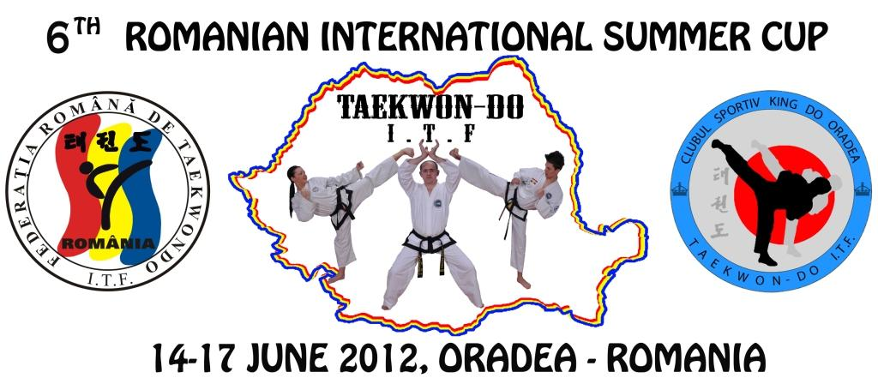

______________________________________________________

INVITATION

The Romanian Federation of Taekwon-do ITF
and C. S. KING DO Oradea in collaboration with
C.S. ROYAL KWON ORADEA and Institution of Sports and Youth
of Bihor county are pleased to invite you to
THE INTERNATIONAL SUMMER CUP, 6TH EDITION

- General information
Period of performance: 14 – 17 June 2012.

Enrollments: Fill in the Enrollment Forms from the www.taekwondo-itf.ro and send them to email: mmvali@yahoo.com until 3th of June 2012. The enrollment to the competition, the verification of the contest charts and fees payments will be made Thursday on 14th of June 2012 in the lobby of the Continental Forum Hotel of Oradea (1 Strandului St.) between the hours: 14,00 – 17,00.
Modifications: any modification of the contests charts made after the enrollment deadline (3 June 2012) will be charged with 5 EURO / each modification (excepting the competitor retirement from some contest event).

Organizator: The Romanian Federation of Taekwon-do I.T.F.(F.R. TKD I.T.F) www.taekwondo-itf.ro

The Organization Board:

President:
Mr. Mircea Muntean – General Registrar of the Romanian of Taekwon-do I.T.F.
Email : mmvali@yahoo.com mobile: 0040 -721 823 410

Local organizer:
Mr.Tulkos Romeo – President of the King-do Taekwon-do Club Oradea.
Email : romi_kingdo@yahoo.com mobile: 0040-747 011062

Local Co-Organizer:
Mr. Tripa Francisc – President of Royal Kwon Taekwon-do Club Oradea.
mobile: 004-0746 796590

Sport hall: The Sport Hall of the ORADEA University, 1 Fagarasului St.

2. FEES
A. The participation to individual pattern and sparring: 10 EUROS (in euros).
A.1. The participation to “A” and individual special technics and/or power test: 15 EUROS (in euro)
B. The participation fee / team 20 EUROS (in euros)– a single payment for all the events, separately for each team – kids, juniors, seniors, males, females;
C. The arbitration fee: (will be of 100 EUROS) represents a warranty for arbitration and will be reimbursed to the clubs after the end of the competition. The attending clubs must provide 1 referee/club. The arbitration fee will not be reimbursed to the clubs that do not have arbiters. The accommodation of one club arbiter is paid by the organizer and is made in one of the places further announced listed on the www.taekwondo-itf.ro .
3. THE CONTEST SCHEDULE:
Thursday- 14th of June 2012:
Arrival to the accommodation places from Oradea before 17.00 hours. The Accommodation confirmations will be sent until 3th of June 2012 at email mmvali@yahoo.com and romi_kingdo@yahoo.com. After this date the Organizer has no responsibility for booking.
12.00 Press Conference;
14.00 – 17:00 Enrollments;
19.30 - 20.30 The Referees Session will take place in the Hall of Continental Forum Hotel of Oradea; The Arbiters will be dressed in arbitration clothes according to the I.T.F. and A.E.T.F. Regulations.
20.30- 21.30 The Technical Meeting for ballot will take place in the Hall of Continental Forum Hotel of Oradea: 1 coach / each club is convoked. Neparticiparea antrenorilor la şedinţa tehnică va fi penalizată cu suma de 25 euro care va fi retrasă din taxa de arbitraj.

Friday 17 June 2011:
08.00- 08.15 – Arrival to the sport hall;
08.30- 13.00 – Contest;
13.00 - 14.45 – Lunch break;
14.45 - 15.00 - Arrival to the sport hall;
15.00 - 20.30 Contest / Prize ceremony

Saturday 18 June 2011:
08.00- 08.15 - Arrival to the sport hall;
08.30- 13.00 – Contest;
13.00 - 14.45 – Lunch break;
14.45 - 15.00 - Arrival to the sport hall;
15.00 - 15.45 The Official Opening of the Contest
15.45 - 20.30 Contest / Prize ceremony

Sunday 19 June 2011
09.00 - 09.15 Arrival to the sport hall;
09.30 – 14.30 Contest;
14.30 - 16.00 Lunch break;
16.00 - 16.30 Arrival to the sport hall;
16.30 - 20.00 Contest/ Prize ceremony;
20.00 - 20.30 The Official Closure of the Contest.

The Contest Regulation: for juniors III, II, I and seniors the competition and arbitration regulation is the one of A.E.T.F. şi F.R. TKD. For juniors III and II the participation to the fight event wearing helmet in the appropriate color of the corner to which the competitor fights is mandatory.

4. Coaches and Referees
Coaches:
a) in the contest room the competitors must wear sport clothing and have a towel on the fight area
b) to the fight one single coach will be present
Referees:
The local Organizer will pay for the accommodation to the hotel or in other place, for a single referee from the attending clubs, starting from Thursday, the 14th of June 2012, hours: 12,00 until Monday, the 18th of June 2012, hours: 12,00.
The arbiters must attend to the Referees Session on Thursday, the 14th of June 2012, hours: 19,30 in the Hall of the Continental Forum Hotel of Oradea. Those who are not present to the arbitration session will be excluded from the arbiters list and lose the accommodation right, and the arbitration fee will not be reimbursed to the clubs to which these competitors are registerd.
5. Categories and contest events: competitors number - 3 competitors / category, and the lowest grade required is 8 Gup (yellow belt).
Juniors III and II (Kids):
- Individual Tull (males and females): - 6 years; -8 years; -10 years; -12 years; -14 years;
- Team Tull: -14 years;
- Individual sparring (males and females): - 6 years; -8 years; -10 years;
- Individual sparring – males (10-12 years): -35 kg ; +35 kg;
- Individual sparring – females (10-12 years): -30 kg; +30 kg;
- Individual sparring – males (12 -14 years) : -33 kg ; -38 kg ; -46 kg ; -52 kg ; + 52 kg;
- Individual sparring – females (12-14 years): -30 kg; -35 kg; -40 kg; -45 kg ; + 45kg;
Juniors I:
  - Individual Tull (male and female): colored belts, I DAN, II DAN
  - Team Pattern: all junior competitors, no children;
  - Individual sparring males: -52 kg ; -58 kg; -63 kg; -70 kg; +70 kg;
  - Female individual sparring: -45 kg; -50 kg; -55 kg ; -60kg; + 60kg
  - Team sparring (minimum 3 competitors, maximum 5 + 1);
  - Individual Power test, force;
  - Team Power test, force (minimum 3 competitors, maximum 5 + 1);
  - Individual special techniques; Special techniques teams (minimum 3 competitors, maximum 5 + 1);
Seniors:
  - Individual Pattern (male and female): colored belt, I DAN, II DAN, III DAN and IV DAN
  - Team Pattern : all senior competitors or maximum 2 juniors in the team;
  - Individual sparring - males: -54 kg; -63 kg; -71 kg; -80 kg; +80 kg;
  - Individual sparring - females: -52 kg; -58 kg; -63 kg; - 70 kg; +70 kg;
  - Team sparring (minimum 3 competitors, or from 5 + 1 competitors, 2 juniors over 17 years may be accepted);
  - Individual Power test, force;
  - Team Power test, force (minimum 3 competitors, maximum 5 + 1);
  - Individual special techniques;
  - Special techniques – teams (minimum 3 competitors, maximum 5 + 1);
Traditional sparring (min. 1 Dan; the team can be mixed or made of 1 junior and 1 senior).
Male sparring for competitors between 35-45 years (old boys), on the following categories: -65 kg; 66-75 kg, 76-85 kg si +85 kg
.
6. Prizes
- Medals and diplomas for 1st , 2nd and 3rd place;
- Cups and diplomas for the general ranking for children, juniors and seniors;
- Medals and diplomas for referees.

7. Confirmation deadlines:
- 03 JUNE 2011 – FOR ACCOMODATION AND ENROLLMENT

8.ACCOMODATION: HOTEL FORUM CONTINENTAL-ORADEA ( * * * * ):
Room 2 or 3 beds………………… 15 euro /bad (person) /night
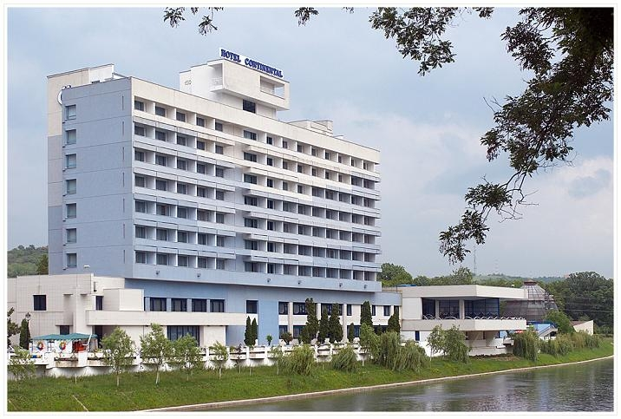
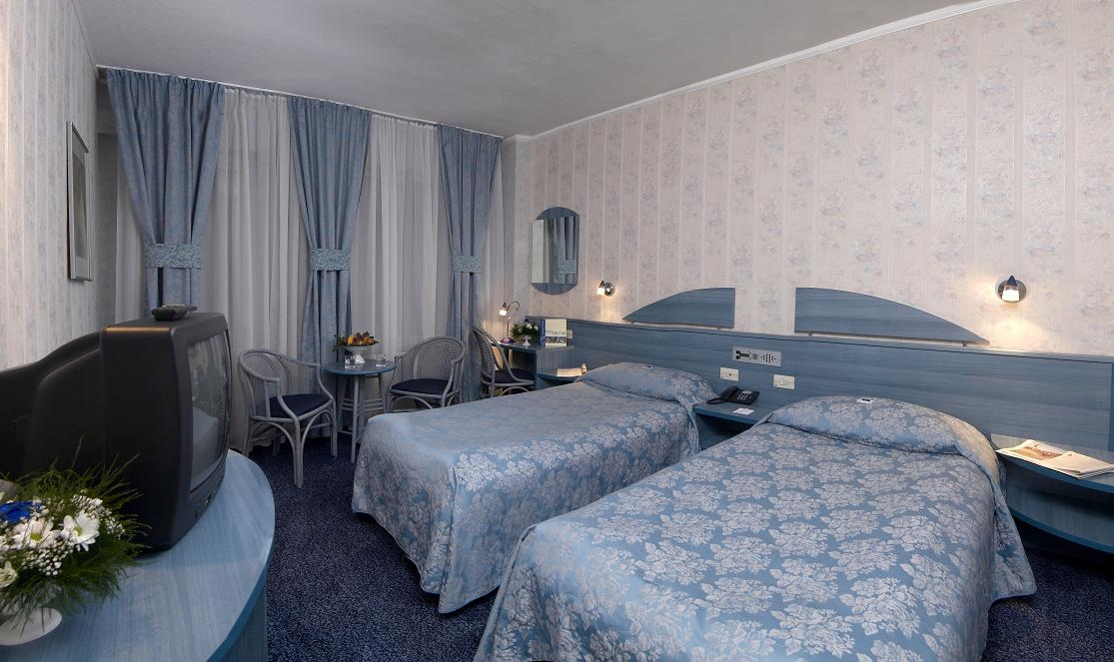
The Hotel provides:
- Guarded car parking: 8 RON (2 EU) / day
- Guarded parking for buses: 15 RON (4 EU) / day
- Pool : 10 RON (2,5 EU) / day / person
- At the FORUM CONTINENTAL hotel, you can have meals (breakfast-15 Ron, lunch-24Ron, dinner-24 Ron), the costs being set at the Reception of the hotel, at arrival.
- Meals are served optionally and are not included in the accommodation price.


9. The competition will be live broadcasted on
www.cristv.ro
During the competition in the contest room there will be a mini bar and a stand with contest and style promotional products (t-shirts, caps, key chains etc.). There will also be stands selling sport equipments.

President of FRTKD General Secretary FRTKD
Marius Oltean – VI Dan Mircea Muntean –V Dan

Local Organizer Co-Organizer
Romeo Tulkos – III Dan Tripa Francisc – IV Dan

