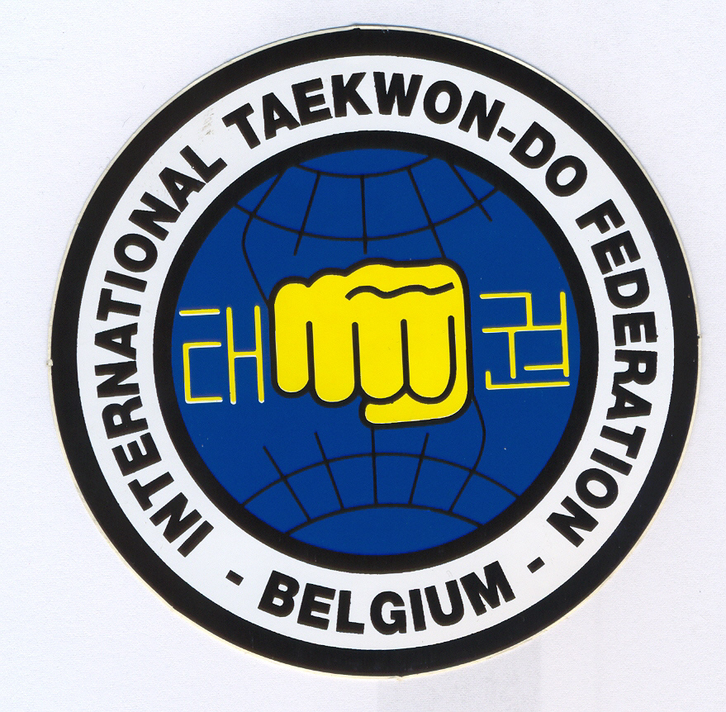

ITF-Belgium has the honour to invite you to the

INTERNATIONAL INSTRUCTORS COURSE

Conducted by the ITF Technical Committee

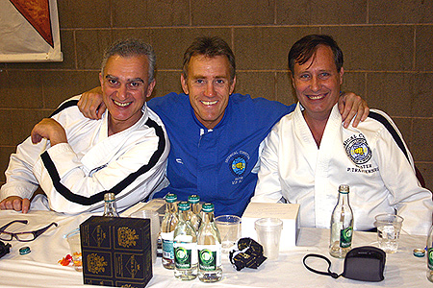

Belgium, Steenokkerzeel (near Brussels)
October 19th-21st 2007

More information & the invitation will be sent to you soon.

Contact : taekwondo1@pandora.be
www.itfbelgium.be

