INTERNATIONAL TAEKWON-DO FEDERATION - BELGIUM

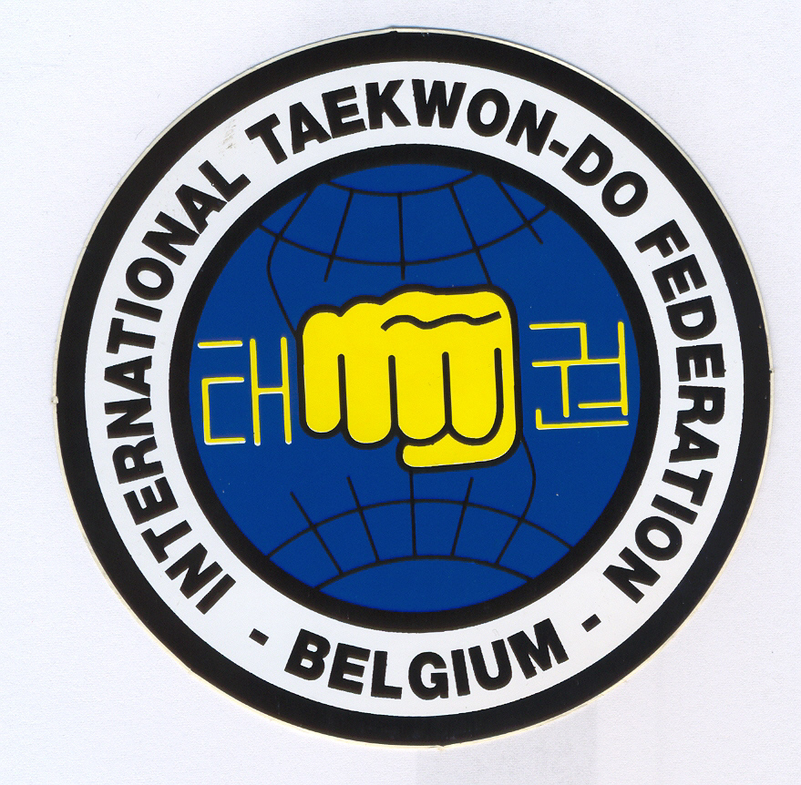
President: Mrs. Annick Van Driessche-Vanberghen V°
Technical Director: Master Frank Vanberghen VII°

Contact address : Toekomstlaan 4 9160 Lokeren Belgium
Tel/Fax : +32-9-384.61.28
Email : taekwondo1@pandora.be

Lokeren, April 17th 2007

To : All ITF Country Members

Subject : International Instructors Course 2007 Belgium

Dear Madam/Sir,

ITF-Belgium has the honor to invite you to the International Instructors Course in Belgium.

Date : October 19th – 21st 2007

Venue : Sporthal Hertblock, Orchideeënlaan 19, Brussels (Steenokkerzeel)

The seminar will be conducted by the ITF Technical Committee: Master Hector Marano (8th degree – Argentina), Master Pablo Trajtenberg (8th degree – Argentina) and Master Willem Jacob Bos (8th degree – Italy).

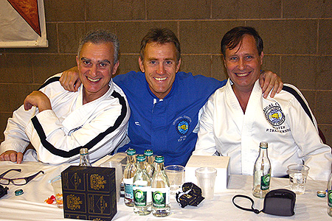
Time schedule :

Friday, 19th October 2007 9.00 – 12.00 seminar
12.00 – 13.00 lunch
13.00 – 16.00 seminar

Saturday, 20th October 2007 9.00 – 12.00 seminar
12.00 – 13.00 lunch
13.00 – 16.00 seminar
18.00 – banquet

Sunday, 21st October 2007 9.00 – 12.00 seminar
12.00 – 13.00 lunch
13.00 - evaluation/grading

Course fees :
- 2° kup up to VI° degree : 120€ course fee + 40€ registration
- VII° degree and above : course fee waved; 40€ registration

Lunch : the sports hall has a cafeteria, with the possibility to have cold and hot snacks during lunch break.

Inscriptions (IIC Individual Inscription Form) : at taekwondo1@pandora.be or fax : +32-9-384.61.28 before October 12th.
Please indicate if you will be present at the banquet when applying for the course.

Accreditation and payment of the course fees : on Friday, 19th October 2007 at the sports hall, 8.00 – 9.00 (course fee, registration and banquet) or in advance on the account 001-2175305-59 (IBAN BE84 0012 1753 0559, BIC GEBABEBB) with name, country & IIC2007.

Gradings on Sunday : please send your application forms in advance (before October 12th), as they have to be send to the Grading Committee.

See the appendix for more information on how to reach the sports hall, hotel accommodation, the banquet and transport..

Yours in taekwondo,

Master Frank Vanberghen Annick Van Driessche
Technical director President
How to reach the sports hall

Sporthal Hertblock
Orchideeënlaan 19 – 1820 Steenokkerzeel (near Brussels – just at Brussels National Airport)

By car

From the direction of Antwerp, take the E19 dir. Brussels, exit 12, Luchthavenlaan N211 & turn right in the direction of Melsbroek/Cargo. At second traffic lights, go left (Haachtsesteenweg). At third traffic lights, turn left and follow the signs “Hertblock”.
From the direction of Mons-Charleroi and Ghent (E40), take the ringroad R0, exit 5 Vilvoorde/Machelen, Woluwelaan & follow the direction Melsbroek/Cargo. At second traffic lights, go left (Haachtsesteenweg). At third traffic lights, turn left and follow the signs “Hertblock”.
From the direction of Luxemburg-Namur (E411), take the ringroad R0 and the E19 dir. Antwerp, exit 12, Luchthavenlaan N211, in the direction of Melsbroek/Cargo. At second traffic lights, go left (Haachtsesteenweg). At third traffic lights, turn left and follow the signs “Hertblock”.

By train

Connections from Brussels-centre and most other cities to the railway station Vilvoorde.
Eurostar and Thalys to Brussels.

In front of the railway station Vilvoorde is a bus stop. Take the bus to Steenokkerzeel, Haachtsesteenweg (200m of the venue).

By plane

To the national airport Brussels (Zaventem). The airport is at 9,8km of the venue.
As Brussels is the capital of Europe, there are direct connections from most countries, also low-fare companies (e.g. SkyEurope, Vueling, …).
www.brusselsairport.be

To the airport Brussels-South (Charleroi) = with the low fare companies Ryanair, WizzAir, Blue Air, OnAir. The airport is at 76km from the venue.
From the airport of Brussels-South, busses leave every hour to Brussels-midi (app. 10€); from Brussels, take a train or bus to the venue.
www.charleroi-airport.com

Hotelaccommodation

Some possibilities near the venue, at Brussels National Airport :

Campanile Brussels Vilvoorde, Luchthavenlaan 2 – 1800 Vilvoorde - At 5,6 km from the venue.

Tel : +32 2 253 97 67
Fax : +32 2 253 97 69
Email : vilvoorde@campanile.com
http://www.campanile.fr/hotel/en-europe/hotel-013194.htm

Campanile Brussels Airport Zaventem, Excelsiorlaan 2 – 1930 Zaventem - At 9,6km from the venue.

Tel : +32 2 720 98 62
Fax : +32 2 720 98 64
Email : brusselsairport@campanile.com
http://www.campanile.fr/hotel/en-europe/hotel-013194.htm

Novotel Brussels Airport, Da Vincilaan 25/Vuurberg – 1831 Diegem - At 7,8km from the venue.

Tel : (+32 )2/7253050
Fax : (+32) 2/7213958
E-mail : H0467@accor.com
http://www.accorhotels.com/accorhotels/fichehotel/nl/nov/0467/fiche_hotel.shtml

Etap Hotel Brussels Airport, Bessenveldstraat – 1831 Diegem/Machelen -
At 8,6km from the venue.

Tel : (+32) 02 709 55 90
Fax : (+32) 02 709 55 95
http://www.accorhotels.com/accorhotels/fichehotel/gb/etp/5247/fiche_hotel.shtml

Formule 1 Brussels Airport, Bessenveldstraat 17a– 1831 Diegem/Machelen - At 8,6km from the venue.

Tel : (+32) 02 725 69 00
Fax : (+32) 02 725 50 17
http://www.accorhotels.com/accorhotels/fichehotel/gb/for/2632/fiche_hotel.shtml#

Hotel Auberge Van Strombeek, Temselaan 6 – 1853 Strombeek-Bever/Grimbergen - At 12km from the venue.

Tel : (+32) 02 460 64 67
Fax : (+32) 02 460 06 70
Email : info@aubergevanstrombeek.be
www.aubergevanstrombeek.be

Other hotels possible near Brussels International Airport & the venue or in Brussels.

Banquet

Take the opportunity to meet & chat with the Masters and the other participants outside of the sports hall, and to have dinner together in a warm atmosphere.

‘t Hof van Welde
Mechelsesteenweg 534
1930 Nossegem-Zaventem
At 4km from the venue, near Brussels National Airport

Saturday, October 20th 2007, start at 18.00h

You’ll have the opportunity to talk to the Masters and the participants to the IIC in a nice & friendly atmosphere.

All inclusive :

Aperitif (aperitif from the house, alcohol free cocktail or fruit juice) & appetizers

Soup

Buffet

Dessert buffet

Coffee

With red and white house wine, beer & soft drinks included.

At 47€ pp

Please make your reservation before October 12th.
Payments on Friday, 19th October 2007 at the sports hall, 8.00 – 9.00 or through the bank account.

Don’t miss this unique chance.

Informal clothing.

