HISTORY OF SLOVENIA OPEN ( 1994- 2006 )

1. SLOVENIAN OPEN

1. Slovenian open was organized at 1994 in Ljubljana. Organizer was TKD KLUB ŠKORPIJON in SLOVENIAN TAEKWON-DO ASSOCIATION.

2. SLOVENIAN OPEN

2. Slovenian open was organized 05.03.1995 in Maribor. Organizer was TKD KLUB BRANIK HWARANG in SLOVENIAN TAEKWON-DO ASSOCIATION.
On tournament can also competited the colouring belts.

Nr.of Countries | Nr.of Competitors. | Nr.of Spectators | Information on
7 | 275 | 600 | http://www.vecer.com

The countries which appear:
CROATIA, HUNGARY, ITALY, CZECH REPUBLIC, HOLLAND, POLAND, SLOVENIA
Famuos competitors:
Grucka Tomasz (POL), Głos Marcin (POL), Wałach Mariusz (POL), Szalay Gábor (HUN)
Head referee :
g. Emin Durakovič (SVN)

3. SLOVENIAN OPEN

3. Slovenian open was organized 23.03.1996 in Maribor. Organizer was TKD KLUB BRANIK HWARANG in SLOVENIAN TAEKWON-DO ASSOCIATION.
The tournament was only for black belts.

Nr.of Countries | Nr.of Competitors. | Nr.of Spectators | Information on
8 | 150 | ------ | http://www.vecer.com

The countries which appear:
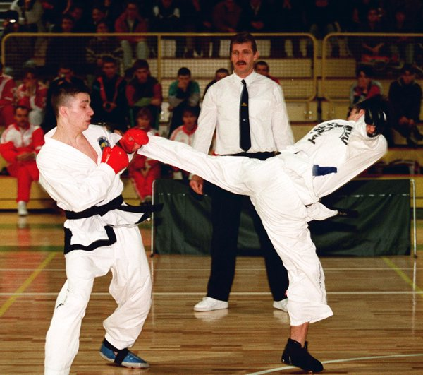
CROATIA, HUNGARY, ITALY, CZECH REPUBLIC, HOLLAND, POLAND, BELGIUM, SLOVENIA
Famuos competitors:
Tapilatu Pattiparu (NLD), Tapilatu Stephan (NLD), Bianca Tapilatu (NLD), Szalay Gábor (HUN), Kołodziej Aneta (POL), Jabłonowska Monika (POL), Pasek Anita (POL), Rogaczewska Małgorzata (POL), Grucka Tomasz (POL), Głos Marcin (POL), Wałach Mariusz (POL), Fabio Calazzo (ITA), Majda Trebše (SVN), Jan Čreslovnik (SVN), Aleš Zemljič (SVN), Drago Zeljkovič (SVN), Matej Eržen (SVN), Tomaž Barada (SVN)
Head referee :
g. Coos v/d Heuvel (NLD)
4. SLOVENIAN OPEN

4. Slovenian open was organized 28.02.1998 in Maribor. Organizer was TKD KLUB BRANIK HWARANG in SLOVENIAN TAEKWON-DO ASSOCIATION.
The tournament was only for black belts.

Nr.of Countries | Nr.of Competitors. | Nr.of Spectators | Information on
7 | 173 | 850 | http://www.vecer.com

The countries which appear:
CROATIA, HUNGARY, ITALY, CZECH REPUBLIC, HOLLAND, CANADA, SLOVENIA
Famuos competitors:
Vidoj Petrovič (NLD), Tapilatu Stephan (NLD), Bianca Tapilatu (NLD), Asztalos Péter (HUN), Majda Trebše (SVN), Jan Čreslovnik (SVN), Robnik Andrej (SVN), Drago Zeljkovič (SVN), Matej Eržen (SVN), Tomaž Barada (SVN)
Head referee :
g. Sebastijan Zemljič (SVN)

5. SLOVENIAN OPEN

5. Slovenian open was organized 27.02.1999 in Maribor. Organizer was TKD KLUB BRANIK HWARANG.
The tournament was only for black belts.

Nr.of Countries | Nr.of Competitors. | Nr.of Spectators | Information on
6 | 133 | 1200 | http://www.vecer.com
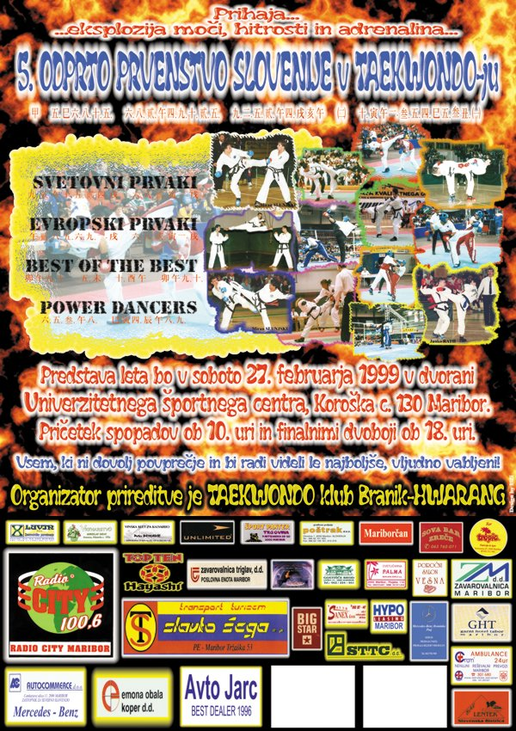
The countries which appear:
CROATIA, HUNGARY, ITALY, CZECH REPUBLIC, HOLLAND, SLOVENIA
Famuos competitors:
Vidoj Petrovič (NLD), Tapilatu Stephan (NLD), Bianca Tapilatu (NLD), Radka Gluha (CZE), Asztalos Péter (HUN), Majda Trebše (SVN), Jan Čreslovnik (SVN), Robnik Andrej (SVN), Drago Zeljkovič (SVN), Matej Eržen (SVN), Tomaž Barada (SVN)
Spectacle:
Tekmovanje zmagovalcev po kategorijah
Tapilatu Stephan (NLD) in Tomaž Barada (SVN) 1 : 3
Head referee :
g. Sebastijan Zemljič (SVN)

6. SLOVENIAN OPEN

6. Slovenian open was organized 26.02.2000 in Maribor. Organizer was TKD KLUB BRANIK HWARANG.
The tournament was only for black belts.

Nr.of Countries | Nr.of Competitors. | Nr.of Spectators | Information on
8 | 153 | 1500 | http://www.vecer.com
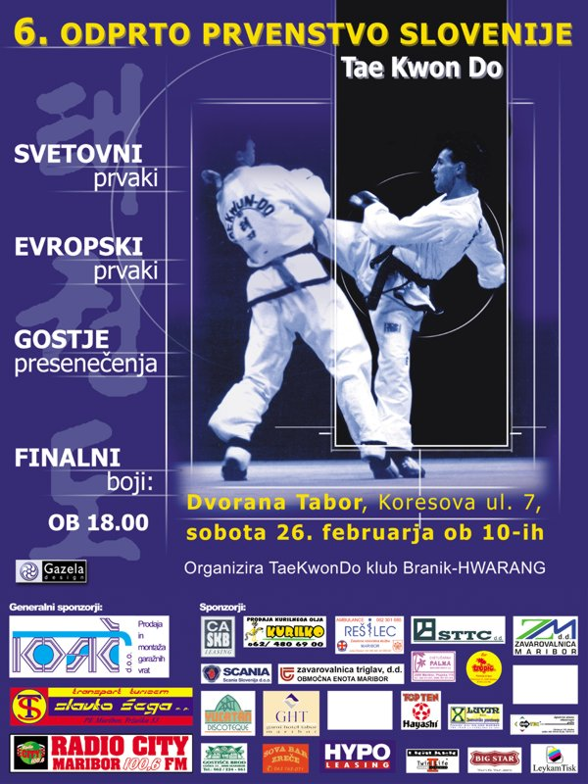
The countries which appear:
CROATIA, BOSNIA AND HERCEGOVINA, POLAND, HUNGARY, ITALY, CZECH REPUBLIC, HOLLAND, SLOVENIA
Famuos competitors:
Vidoj Petrovič (NLD), Richard Sie (NLD), Jan Mraček (CZE), Radka Gluha (CZE), Asztalos Péter (HUN), Zelg Galešič (CRO), Majda Trebše (SVN), Tomaž Borko (SVN), Aleš Zemljič (SVN), Matej Eržen (SVN), Redžo Ljutič (SVN), Mateja Raboteg (SOL), Tomaž Barada (SVN)
Spectacle:
Repeat the team final sparing from WC in Argentina 1999 SLOVENIJA – POLSKA
Borko - Vauvah 0:2
Zemljič - Pilasz 1:1
Ornik – Pilkowski 0:2
Barada - T. Idzikowski 2:0
Pungartnik - D. Idzikowski 0:2
Tudi tokrat so bili Poljaki uspešnejši, rezultat pa je bil enak kot v Argentini. 3 : 7
Head referee :
g. Sebastijan Zemljič (SVN)

7. SLOVENIAN OPEN

7. Slovenian open was organized 24.02.2001 in Maribor. Organizer was TKD KLUB BRANIK HWARANG.
The tournament was only for black belts.

Nr.of Countries | Nr.of Competitors. | Nr.of Spectators | Information on
9 | 236 | 1000 | http://www.vecer.com
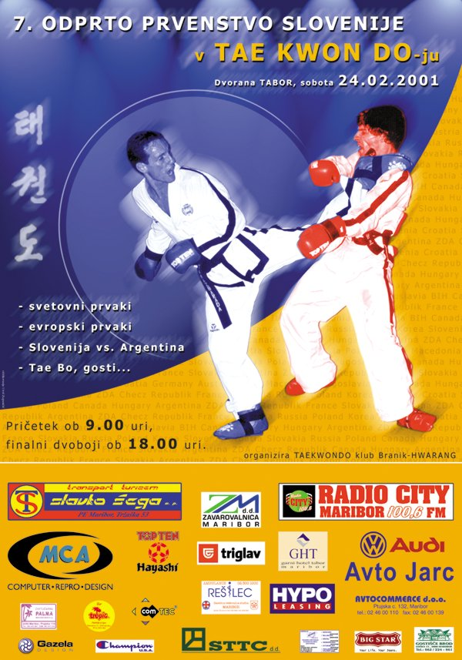
The countries which appear:
CROATIA, BOSNIA AND HERCEGOVINA, HUNGARY, ITALY, AUSTRIA, ARGENTINA, GERMANY, NOLLAND, SLOVENIA
Famuos competitors:
Vidoj Petrovič (NLD), Bianca Tapilatu (NLD), Thomas Pfafel (GER), Zelg Galešič (CRO), Pascual Jana (ARG), Pascual Federico (ARG), Figari Federico (ARG), Nuša Rajher (SVN), Aleš Zemljič (SVN), Tomaž Borko (SVN), Matej Eržen (SVN), Redžo Ljutič (SVN), Tomaž Barada (SVN)
Spectacle:
Argentina – Slovenija 6:4
Head referee :
g. Sebastijan Zemljič (SVN)

8. SLOVENIAN OPEN

8. Slovenian open was organized 23.02.2002 in Maribor. Organizer was TKD KLUB BRANIK HWARANG.
The tournament was only for black belts.

Nr.of Countries | Nr.of Competitors. | Nr.of Spectators | Information on
13 | 135 | 950 | http://www.vecer.com
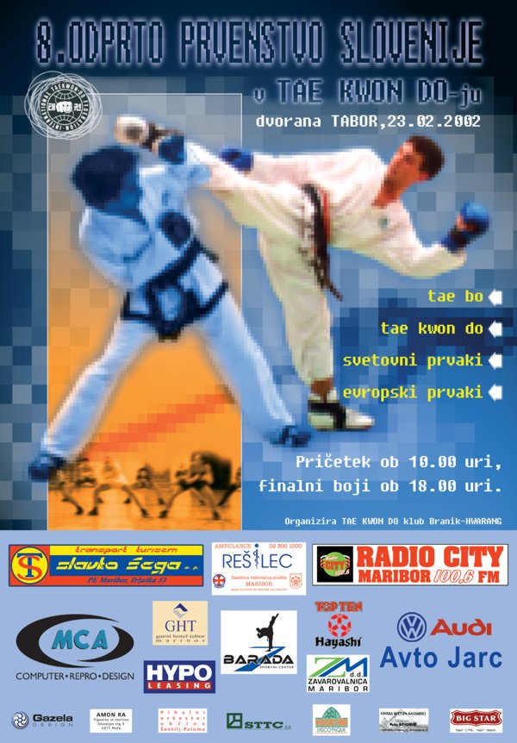
The countries which appear:
CROATIA, BOSNIA AND HERCEGOVINA, HUNGARY, ITALY, AUSTRIA, JAPAN, ARGENTINA, GERMANY, CZECH REPUBLIC, WELS, POLAND, HOLLAND, SLOVENIA
Famuos competitors:
Vidoj Petrovič (NLD), Su Il Hwang (JAP), Neil Ernest (WEL), Anita Pasek (POL), Lipa Joanna (POL), Zelg Galešič (CRO), Pascual Jana (ARG), Pascual Federico (ARG), Figari Federico (ARG), Nuša Rajher (SVN), Aleš Zemljič (SVN), Tomaž Borko (SVN), Redžo Ljutič (SVN), Andrej Sande (SVN), Mateja Raboteg (SOL), Tomaž Barada (SVN)
Head referee :
g. Sebastijan Zemljič (SVN)

9. SLOVENIAN OPEN

9. Slovenian open was organized 18.02.2006 in Maribor. Organizer was TKD KLUB BB HWARANG.
The tournament was only for black belts.

Nr.of Countries | Nr.of Competitors. | Nr.of Spectators | Information on
10 | 174 | 950 | http://www.itfeurope.org/NL2006-01-24.html
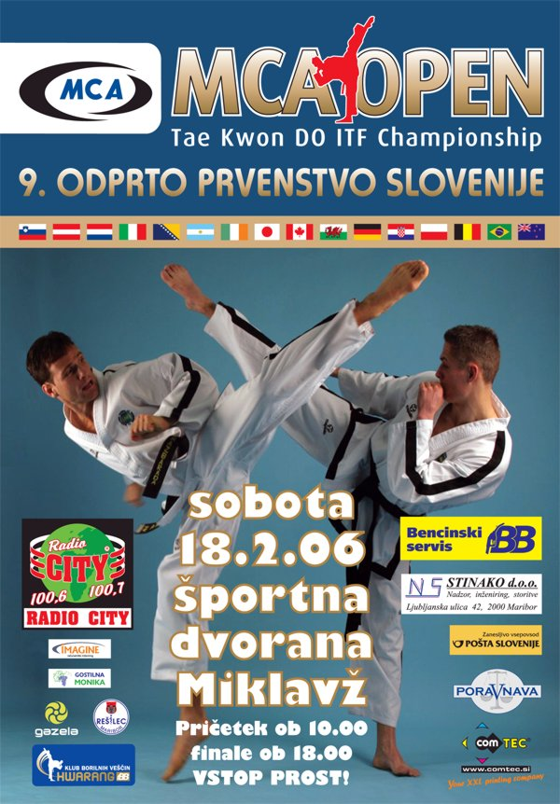
The countries which appear:
BOSNIA AND HERZEGOVINA, CROATIA, HUNGARY, IRELAND, POLAND, NETHERLANDS, NEW ZEALAND, SLOVAKIA, UKRAINE AND SLOVENIA
Famuos competitors:
Aleš Zemljič (SVN), Redžo Ljutič (SVN)
Head referee :
g. Sebastijan Zemljič (SVN)

EXTRACT

All this names of competitors from last 13 years of Slovenian open we see that this tournament is one of heavies clubs tournament in Europe. The competitors can get a lot of expirience, because on this tournament compete a many European and World champions. The final competition is a special event because is it a very good atmosphere in Maribor. The all Maribor is in that time in spirit of TAEKWON-DO.

Best regards
Sebastijan Zemljič IV DAN

