

Dear Presidents, Masters, Instructors

I have pleasure to invite you to International Taekwon-Do Seminar which will be held on 28.-30. Oct. 2005 in Ylöjärvi, Finland.

The seminar will be conducted by Grandmaster Van Binh Nguyen, IX degree, Chairman of the Master Promotion Committee of ITF and Master Tran Trieu Quan, VIII Degree, ITF President.

The trainings will concentrate on self-defense, the “DO”, patterns, basic techniques and internal energy.

I am looking forward to see you soon in Finland.

Best regards,


Mariusz Steckiewicz
President, ITF Taekwon-Do Finland
+358 40 538 1020
email: president@taekwon-do.fi

International Taekwon-Do Seminar
with:
Grandmaster Van Binh Nguyen, IX Degree
Master Tran Trieu Quan, VIII Degree

Seminar details:

Organizer: Taekwon-Do Center
Mariusz Steckiewicz,
GSM: +358 40 538 1020
Email: president@taekwon-do.fi
http://www.tkd-center.net

Promotor: ITF Taekwon-Do Finland (Suomen ITF Taekwon-Do ry)
http://www.taekwon-do.fi

Open to: All color and black belts.

Schedule:

Friday, 28. Oct 2005 17.00-17.45 registration and payments at the training hall
18.00-20.00 training

Saturday, 29. Oct 2005 10.00-13.00 training
16.00-18.00 training

Sunday, 30. Oct 2005 10.00-13.00 training
15.00-17.00 examination for black belt holders

Fee: 95 € (including seminar fee and T-shirt)

Venue: Ylöjärven lukio (High School of Ylöjärvi)
Kuusistontie 1, 33480 Ylöjärvi

Inscriptions please email inscription form on or before Thursday 20th of October 2005
to: president@taekwon-do.fi

Payments: please make transfer to the bank account:
From abroad:
Taekwon-Do Center:
Ålandsbanken:
IBAN: FI68 6601 0001 1839 79
SWIFT/BIC: AABAFI22

From Finland:
Taekwon-Do Center:
Ålandsbanken: 660100-01183979

We accept payments also at the registration (cash only, in euro).
Deadline for sending inscription form is latest on Thursday, 20th of October.
How to get to Tampere?

By plane:
Number of Airlines including budget operators (Blue 1, Ryanair) has Tampere as their destination. Pirkkala airport is located 12 km from Tampere center.

By car:
Tampere is located 170 km North from the capital city of Helsinki and 150 km East-North from Turku.

For more detailed traveling instructions please contact:
Ms Saija Steckiewicz, GSM +358 40 555 7888, Saija@pp1.inet.fi

Persons in need of hotel, hostel or school accommodation, please contact:
saija@pp1.inet.fi before: 7th of October.

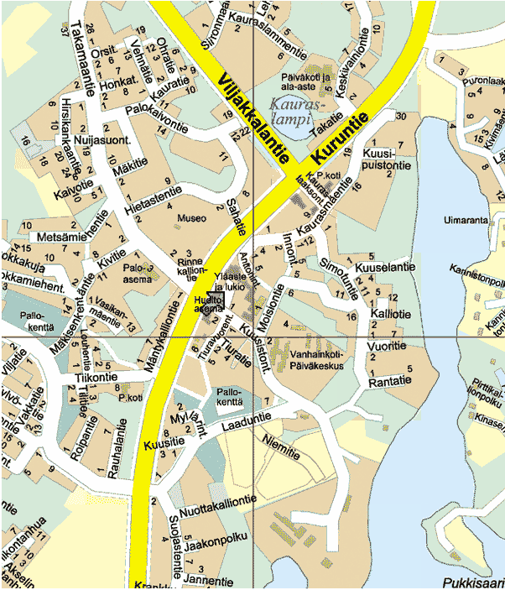
Map: http://ylojarvi.kuntanet.fi/mp/map/AX=2566&AY=1246&K=taajama-alue&X=2558&Y=1239&prevz=1&view=800&z=0

