Docklands Taekwon-do

6th Summer Camp - 2006

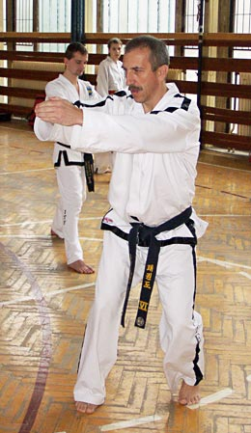
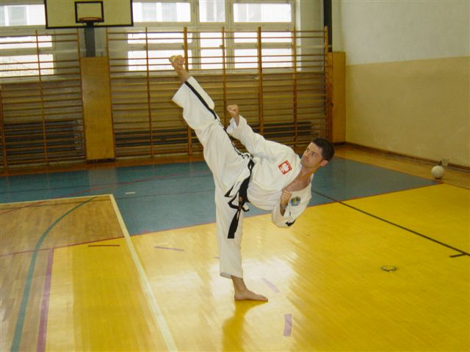

Mr J Jedut VI Degree
Chief of the technical matters, PZTKD Polish National Team Coach (1987-95). Teacher of many renowned TKD practitioners who have won countless World and European championships.

Also in attendance will be some of his students.
Mr J Suska
V Degree
International-class competitor, the 14 times Champion of Europe and twice world champion in patterns. The best Polish technical practitioner in the history of Polish TaeKwon-Do

Summer camp will run from
Thursday 10th August – Sunday 13th August

Thur 10th – Sun 13th
Langdon Park Sports & Community Centre
35 Byron Street
Poplar, LONDON E14 0RY


Contact the host using the application form to book your place.

Host: Mr T Denis VI Degree - Tel: 020 7537 0079 or 07727 044921
E-mail: tdenistkd@bulldoghome.com

Prices: 4 days training = £100; 3 days training = £80, 2 days training = £60, 1 days training = £40

Please indicate below which days you will be attending

Thursday 10th Friday 11th Saturday 12th Sunday 13th

Name: ________________________________________

School: _______________________________________ Grade: ___________

(Please send payment with form, made payable to Docklands Taekwon-Do, by 31st July 2005 to Mr T Denis, 32 Charnwood Gardens, Timber Wharf, LONDON E14 9WD)

Late entries will incur a £10 surcharge.

