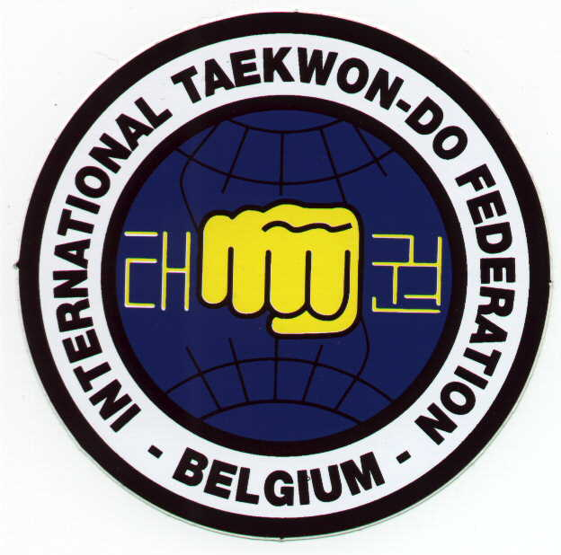
Invitation

Waasland Cup 2007
Fundraising championship for Eric

ITF Taekwon-Do

Tul & sparring

An organization of taekwon-do school «Koryo » & ITF-Vlaanderen eV vzw

Saturday, December 1st 2007

Sporthal « De Witte Molen »
Azalealaan 29, 9100 Sint-Niklaas

Organizers :

Koryo :

Mr. & Mrs. Stefaan & Els De Ridder – De Maeyer

Tel. : +32-4-86.18.38.90

Mr. Peter Van Puyvelde

& ITF-Vlaanderen eV vzw :

taekwondo1@pandora.be - Tel./Fax : +32-9-384.61.28

Tournament organizer & contact address for all entries :
Master Frank Vanberghen
Toekomstlaan 4 – 9160 Lokeren – Belgium

Tel/Fax : +32-9-384.61.28 Email : taekwondo1@pandora.be

Head referee :

Mr. Eddy Van Damme

Weigh-in : 8.30h – 9.30h Start : 10h

Entry fee :

- Members ITF-Belgium : - 1 discipline : 10€

- 2 disciplines : 15€
- Other participants : - 1 discipline : 15€

- 2 disciplines : 20€

Spectator’s entrance fee : 0 €

Closing date for all entries : 18th November 2007.

Annulations only possible until November 25th, after this date the inscription fee will be charged.
If competitors need to be transferred to an other category on the day of the tournament, 10€ will be charged.

Referees

All referees have to wear the dress requirements, as laid down in the ITF umpire rules. The ITF-system will be used (KO-system).

HARD CONTACT WILL NOT BE ALLOWED.

- 1-6 participants : at least 1 referee

- 7-12 participants : at least 2 referees

- 13 or more participants : at least 3 referees

- Per missing referee, 25€ will be charged.

This tournament is a fundraising championship, so we hope more referees will attend the tournament. A meal will be available during lunch break for full-time referees.

Rules

All participants have to wear an official ITF dobok; semi-contact feet- and hand protections (open hand, covering fingers), and groin guard (for males) obliged; shin protections, mouth guard and head protection allowed; only ITF approved safety equipment will be allowed (no boxing gloves, no open gloves).

In case of protest, the ITF rules will be followed (the coach can fill in a protest form within 5 minutes and give it to the head referee, with 25€).

Remark:

Because each inscription is linked with a club, the teacher of this club is responsible for the insurance of their students.

Categories

TUL :

Male & female together, separate classes for juniors (-18years) & seniors (18 and above).

Coloured belts | Participants will perform 1 optional tul (KO-system).
10°-9°kup | Sayu chirugi - Chon-ji
8°-7°kup | Sayu chirugi – Do-san
6°-5°kup | Chon-ji – Yul-gok
4°-3°kup | Chon-ji – Toi-gye
2°-1°kup | Chon-ji – Choong-moo
Black belts | Participants have to perform 1 optional and 1 designated tul (KO-system; ITF rules will be followed).
I°degree | Chon-ji – GeBaek
II°degree | Chon-ji – Juche
III°degree | Chon-ji – Yoo-sin
IV°-VI° degree | Chon-ji – Moon-moo

If there is only 1 competitor in a category, the organization will put classes together.

There will be 2 third places. In the event of a tie competitors will compete once more with designated tul until the places are decided.

SPARRING:

Separate classes for males & females; separate classes for juniors (-18y) and seniors (18y and above).

Duration of the bout : white-blue belts : 1x2’, red-black belts : 2x2’

Weight – height
Junior | -130cm, -140cm, -150cm, -160cm, -170cm, +170cm
Senior female | -52kg, -58kg, -63kg, -70kg, +70kg
Senior male | -54kg, -63kg, -71kg, -80kg, +80kg
Belts
10°kup-7°kup
6°kup-3°kup
2°kup – VI°dan

If there is only 1 competitor in a category, the organization will put classes together.

There will be 2 third places.

ENTRY FORM

Name school
City
Contact person
Address
Tel
Email
Name coach(es)

Referees :
Name | Degree | Qualification  (A/B/none) | Preference  (center/corner/jury pr)
1.
2.
3.
4.
5.
6.
7.

TUL:
Name | Kup/Degree | Birthdate (junior/senior)
1.
2.
3.
4.
5.
6.
7.
8.
9.
10.
11.
12.
13.
14.
15.
16.
17.
18.
19.
20.
21.
22.
23.
24.
25.

SPARRING:
Name | Kup/Degree | Birthdate  (junior/senior) | Weight/  height | Male/  Female
1.
2.
3.
4.
5.
6.
7.
8.
9.
10.
11.
12.
13.
14.
15.
16.
17.
18.
19.
20.
21.
22.
23.
24.
25.

Dear Masters, Instructors & friends,

Recently Eric Van Puyvelde, brother of Peter Van Puyvelde (I°degree, student of Koryo & member of the national team) had a sincere accident. As a result, he’s paralysed.
As revalidation costs are very high, the idea was suggested to organise an ITF Taekwon-do tournament for fundraising, a championship for Eric . Therefore we’ll have this “Waasland Cup 2007” fundraising championship for Eric.

A lot of persons will help to make this event possible.
Main organisers are Stefaan and Els De Ridder-De Maeyer (instructors of Koryo) and Peter Van Puyvelde, together with ITF-Vlaanderen eV vzw.

I hope you’ll all be present on this championship, to support Eric and this fundraising tournament.

Best regards,

Annick Van Driessche-Vanberghen
President ITF-Vlaanderen & ITF-Belgium

taekwondo1@pandora.be
+32-9-384.61.28
