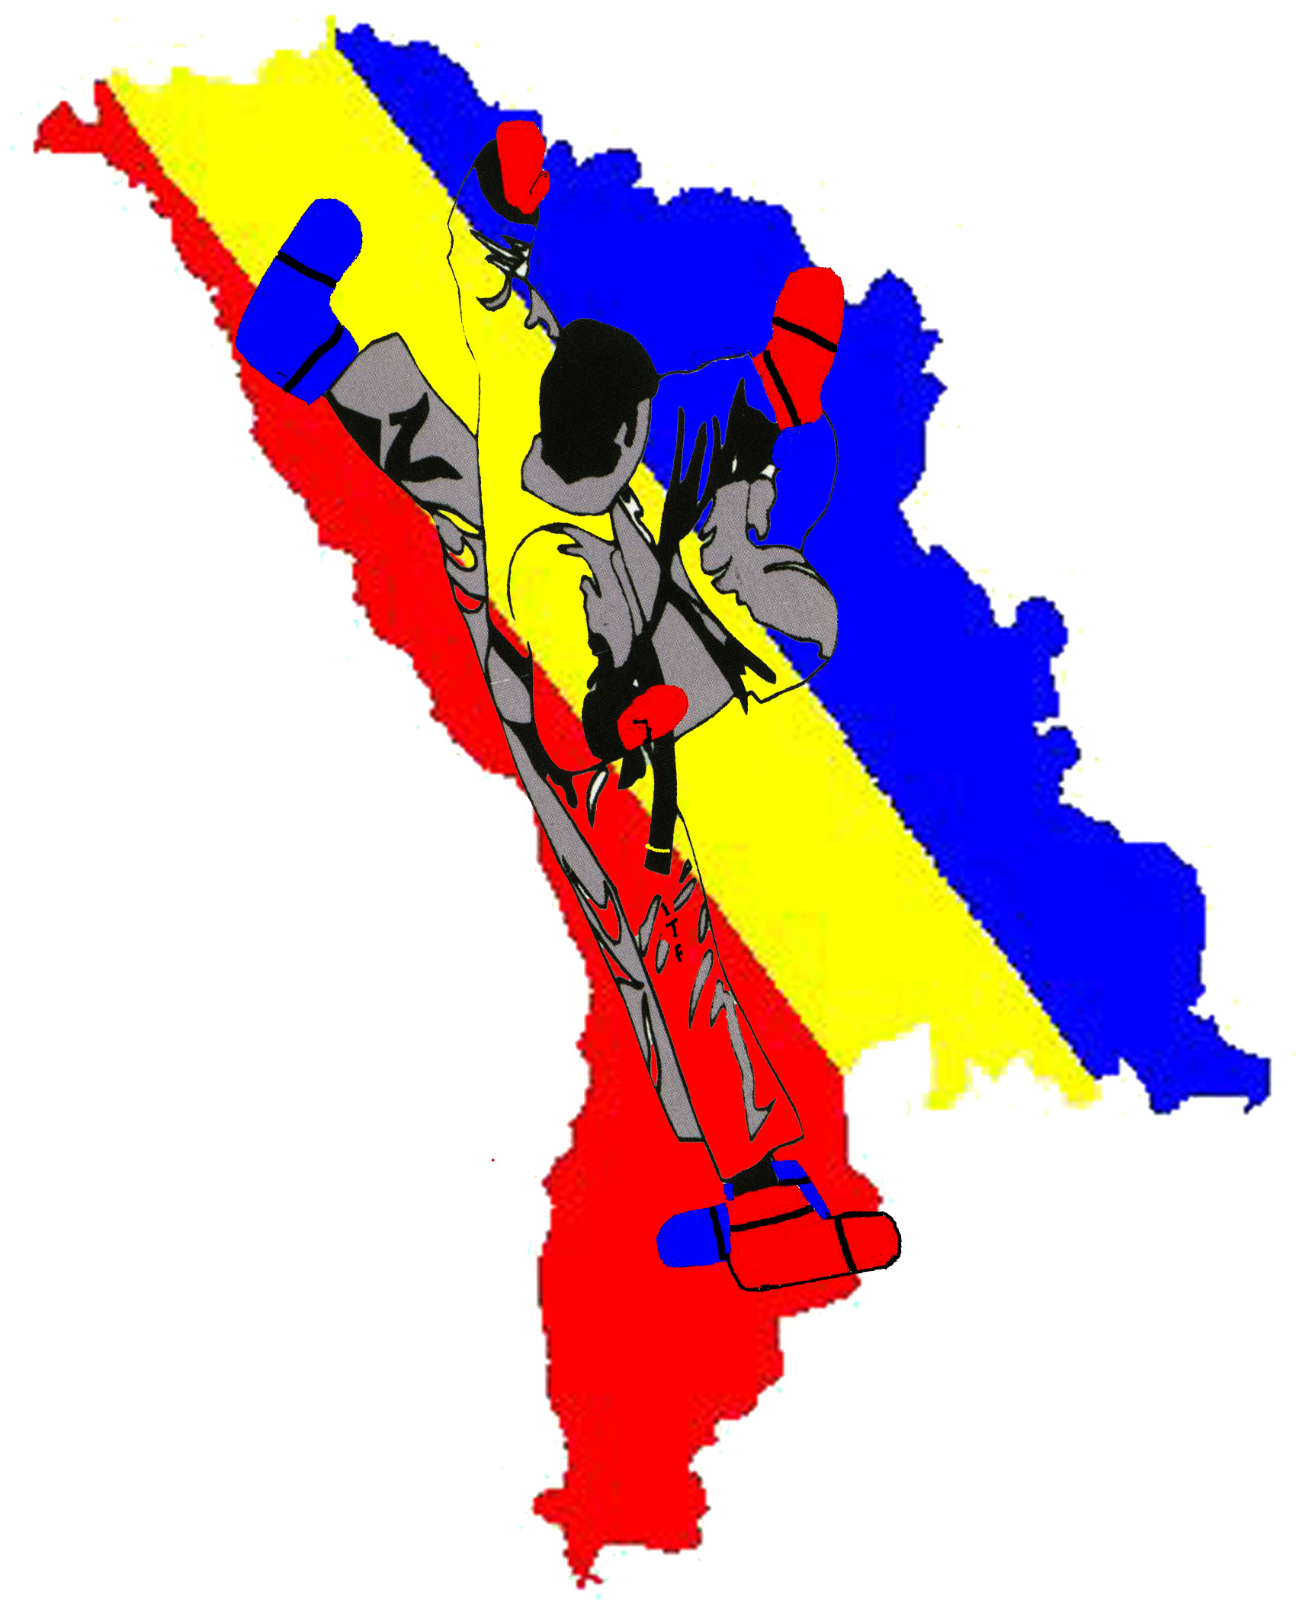

CHIŞINĂU 2008

Chisinau, January 2nd, 2008

Dear President, Master or Instructor,

We invited you and your students to participate in the CHAMPIONSHIP the REPUBLIC of MOLDOVA on TAEKWON-DO ITF - 2008

The Championship open for Kids (6-13 years old), juniors (14-17 years old) and seniors (18 years and above) and will be held in Chisinau, the Republic of Moldova on February 23-24th, 2008.
The competition includes Individual-Patterns, Sparring, Special Technique, Power Breaking and Team - Sparring, Special Technique; Power Breaking is open to Colored and Black Belts, Male and Female.

Looking forward to seeing you in Chisinau!

Mr. Sergiu Sloninov

PRESIDENT F.N.T.R.M.
VI DAN

General Information

SANCTIONED BY:

AGENCY OF SPORT the REPUBLIC of MOLDOVA
NATIONAL TAEKWON-DO FEDERATION the REPUBLIC of MOLDOVA

The Cempeonship will be held in Chisinau
Date: 23-24 February 2008
Organizers: TKD Club Olimpus
Tel. Contacts: +37379 45 63 45 or +37369 11 15 10
E-mail: info@taekwondo.md
Web: www.taekwondo.md

REGULATIONS FOR COMPETITORS, COACHES & OFFICIALS:

Umpires:
- Umpires shall wear the official ITF umpire uniform (white long sleeve shirt, blue tie, blue pants, white sports shoes and white socks).

Coaches:
- Shall wear training suit or a T-shirt, pants (long or short) and running shoes.
- Only one (1) coach is allowed in the competitor area
- Only coaches are allowed to present an official protest. The protest should be given with the monetary mortgage – 50 € (Euro). At satisfaction of the protest, the mortgage comes back. At a deviation of the protest, the mortgage does not come back.
- They should bring with them two national country flags

Competitors:
- Must wear official Taekwon-do ITF uniform.
- Shall be in possession of a red & blue pair of approved sparring equipment
- Everybody has to present medical insurance; persons who did not present medical insurance will not be able to pass accreditation

Awards for Participants:
- All prize-winners of competitions in personal categories will get medals and diplomas.

- Cups to the absolute winners in individual competition
- Cups to the absolute winners in clubs competition

VISA:

The delegations of visa-requiring countries must contact the Moldova Embassy in their country and give an official invitation letter of the Organizing Committee with other documents. You also must send a list with the names (first and last name), dates of birth and the dates of issue and expiry of the passports of all those traveling to the Organizing Committee Chairman in order to give you visa support.
Very important: please send as soon as possible the invitation form.

ABOUT MOLDOVA:

The Republic of Moldova is a country located in south eastern Europe. This country s capital is Chisinau. Chisinau is a very green city and Moldovans are likeable people. The fertile and black land is so rich in nutrients that one old saying goes, "Thrust a stick into Moldovan ground and it will grow into a tree." Much of Moldova is a steppe to the Carpathian Mountain range, possessing the perfect soil for wine production. Moldova produces a variety of excellent wines . It is also home to the world s largest underground wine cellars at “Cricova”. It is a must for any wine connoisseur. So, is the annual Wine festival every autumn , organized in conjunction with the Moldovan state which offers foreign visitors the chance to taste moldovan wine. The annual festival is a tribute to all professional and non-professional wine-makers for their hard work and maintaining the old wine-making traditions of the republic. Anywhere on earth you will find good and bad people. That is a given. Moldova however seems to have a disproportionate number of good people. Reliable, trustworthy, friends of life. It s has been said if you can count your true friends on the five fingers of your hands, you are rich. If that s true, then Moldova stands to make you a very rich person. www.turism.md

TRANSPORTATION:

The internal transportation will be assured.
Please, specify an arrival time and a type of transport (number of flight or a train, the name of airline or station): _______ we specify

ACCOMMODATION PACKAGES:

Duration of stay | Package “C”  (2 Star hotel)  Prices per person per day  Included breakfast  sharing a double and triple room | Package “B”  (3 Star hotel)  Prices per person per day  Included breakfast  sharing a double room | Package “A”  (4 Star hotel)  Prices per person per day  Included breakfast  sharing a double room
1 night : | Euro 20 | Euro 40 | Euro 80
2 nights : | Euro 40 | Euro 80 | Euro 160
3 nights : | Euro 60 | Euro120 | Euro 240
for a single room ad: | 10 Euro per day | 15 Euro per day | 25 Euro per day

COMPETITORS SPORTS PROGRAM

Friday February15 2008

Arrivals at “Labour Institute” ( Institutul Muncii) in Chisinau, Moldova, Zimbrului 10 str., before 14.00 p.m. for accreditation, Weight Control and payments of the following fees:
- competitors competition entry fee: Euro 15.00
- hotel accommodation (see chapter on Hotel accommodation)

18.00-19.30 umpire meeting in “Labour Institute” in Chisinau, Moldova, Zimbrului 10 str
20.00 dinner
21.30-22.30 coach meeting in “Labour Institute” in Chisinau, Moldova, Zimbrului 10 str

Saturday February16 2008

07.00 – 08.00 breakfast
08.00 departure by bus to the Sport Complex
08.30 – 12.30 competition
12.30 departure by bus for lunch
14.30 departure by bus to the Sport Complex
15.00 – 16.00 official opening ceremony
16.00 – 20.45 competition/finals/medal awarding
20.45 departure for hotels
21.00 dinner

Sunday February17 2008
07.00 – 08.00 breakfast
08.00 departure by bus to the Sport Sport Complex
08.30 – 12.30 competition
12.30 departure by bus for lunch
14.30 departure by bus to the Sport Complex
15.00 – 20.00 competition/finals/medal awarding
20.00 – 20.45 closing ceremony
20.45 departure for hotels
21.00 dinner
22.00 party – place to be decided

Monday February18 2008
Breakfast and departure

DIVISIONS AND/OR CATEGORIES

INDIVIDUAL
Tull and Sparring

- Kids:
Tull (M/F): - 8 years; - 11 years; - 13 years
Sparring (M/F): -13 years
(M) - 20 kg ; - 25 kg ; - 30 kg; - 35 kg ; - 40kg; -45kg;+45 kg ;
(F) –25 kg; -30 kg; -40 kg; + 40 kg;

- Juniors: (-18 years)
Tull (M/F) – Black Belt: I Dan +; Color Belt;
Sparring (M/F) –
(M) -52 kg, -58 kg, -63 kg, -70 kg, +70 kg ;
(F) -45 kg, -50 kg, -55 kg, -60 kg,+60 kg.

- Seniors: (+ 18 years)
Tull (M/F) - Black Belt: I Dan +; Color Belt;
Sparring (M/F) –
(M) -54 kg, -63 kg, -71 kg, -80 kg, +80 kg;
(F) -52 kg, -58 kg, -63 kg, -70 kg, + 70 kg.

Special Technique and Power Breaking:

The sportsmen on categories according to the bottom table can participate.
Each of the participants past accreditation will make through passage impact, which will be chosen by the judges by a toss-up. Those sportsmen, which have collected point, will spend other impacts and by summation the winner will be determined.
TEAM
Sparring, Special Technique; Power Breaking

The team should be made not less than 5 sportsmen and 1 in a stock at wills, it is possible in common from juniors and seniors.
Sparring - Olympic system
Special Technique and Power Breaking -System of summation of point

Power Breaking | senior M  boards/heights | senior F  boards/heights | junior M  boards/heights | junior F  boards/heights | Kids -- 13 years M | Kids -- 13 years F
ap - joomuk jirugi | 3 |  | 2
sonkal taerigi | 3 | 2 | 2 | 1
yopcha taerigi | 5 | 3 | 4 | 2
dollyo chagi | 4 | 2 | 3 | 1
bandae dollyo chagi | 4 |  | 3
Special Techniques
twimyo nopi ap cha busigi | 270 | 230 | 260 | 210 | 180 | 170
twimyo nomo yop cha jirugi | 290 | 200 | 260 | 200 | 150 | 140
twio dolmyo yop cha jirugi | 240 |  | 230
twimyo dollyo chagi | 250 | 210 | 240 | 200 | 170 | 160
twimyo bandae dollyo chagi | 240 |  | 230

List of delegation

COUNTRY: _________________
VIPs
No | NAME | Nr Passport | Date of Birth | FUNCTION

Umpires
No | NAME | Nr Passport | Date of Birth | FUNCTION

Coaches
No | NAME | Nr Passport | Date of Birth | FUNCTION

Team Competitors
No | NAME | Nr Passport | Date of Birth | FUNCTION

Others:( supporters, doctor, pres agent)
No | NAME | Nr Passport | Date of Birth | FUNCTION

Application Form
Name of the Club/Federation
Address, telephone, E-mail:
Head of delegation:
Referee: | 1. |  | 2.
 | 3. |  | 4.
Team Coach | 1. |  | 2.
 | 3. |  | 4.

APPLICATION FORM FOR SENIORS

N | Competitor’s  surname and forename | Sex (F) (M) | Date  of birth | Individual
 |  |  |  | Pattern |  |  |  | Sparring |  |  |  |  |  | Sp. tech. | Pow. test
 |  |  |  | Colored Belt | I | III | III, IV | -54/-52 | -63/-58 | -71/-63 | -80/-70 | +80/+70 | Team | Sp. tech. | Pow. test

APPLICATION FORM FOR JUNIORS

N | Competitor’s  surname and forename | Sex (F) (M) | Date  of birth | Individual
 |  |  |  | Pattern |  |  | Sparring |  |  |  |  |  | Sp. tech. | Pow. test
 |  |  |  | Colored Belt | I | II | -52 / -42 | -58/-48 | -63/ -53 | -70/ -60 | +70/ +60 | Team | Sp. tech. | Pow. test

APPLICATION FORM FOR KIDS

N | Competitor’s  surname and forename | Sex (F) (M) | Date  of birth | Individual
 |  |  |  | Pattern |  | Sparring
 |  |  |  | 10th Kup to 5th Kup | 4rd Kup to 1st Kup | -20 / -20 | -25 / -30 | -30/-40 | -35/ -45 | -40/ +45 | -45 | +45

APPLICATION FORM FOR TEAM COMPETITION

N | Competitor’s  surname and forename | Sex (F) (M) | Date  of birth | TEAM
 |  |  |  | Sparring | Sp. tech. | Pow. test

Hotel accommodation application form
Country, school, gym: __________________________________

Responsable:____________________________________________________________

tel/fax:_________________mobile:________________e-mail:_____________________

please book for a total of ______persons ( include competitors, umpires, supports, others)

№ | Name, Surname | Status | Date of arrival | Date of departure | Type Package  (A,B,C,) | Type of number (1-place.s or  2-place.s)

Total: single rooms _________ double rooms _________
Please, specify an arrival time and a type of transport (number of flight or a train, the name of airline or station):
Our arrival by _________________________on ____________________
Plane, bus train, car day and date

Our departure on __________________________________
day and date

Date:____________________ Head of delegation: ____________________

Agriment ” The responsibility in case of a trauma”

ORGANIZATOR: Clubul TKD Olimpus
PLACE: Chişinău
NAME of CLUB: _________________________________________
INSTRUCTOR: ____________________________________________________
I have familiarized and I confirm that all traumas, which can be received in result participating in a Championship of Republic of Moldova on Taekwon - do ITF 2008 of February 16-17 following sportsmen, TKD club Olimpus does not carry what moral or liability, in what I undersign.
Nr. | Name, Surname | Sportsmen signature

Head of delegation: Name/Surname…………………......................................................

Signature
...................................
(Seal)
Deadlines for following items:

Application forms and photos of all participants/others must be send before or on the deadline
of 21th February, 2008 to e-mail:

info@taekwondo.md

English variant of the given invitation is valid only for teams coming and for abroad the Republic of Moldova.

