BATTLE OF UTRECHT

SEPTEMBER 30 2007


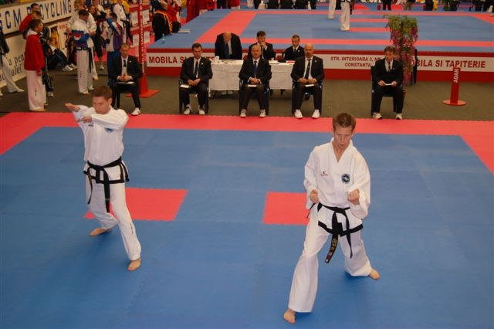
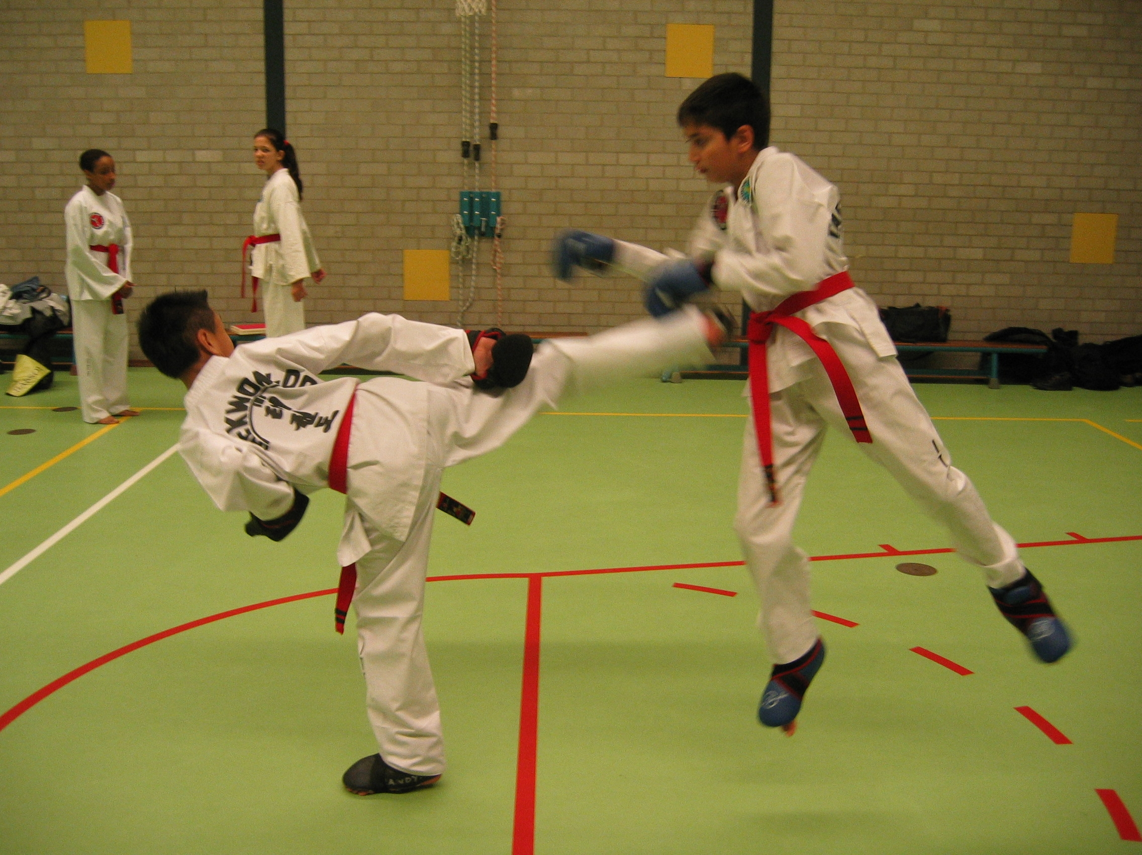
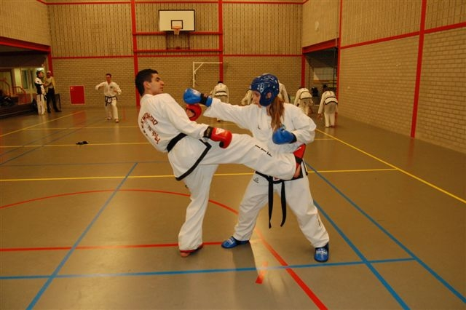

SPARRING & TULS
youth, junior and senior



Battle of Utrecht is part of the Pro League Tournament
www.promatour.com

Utrecht, sporthal Lunetten

Registration before 23 september 2007

organization James Tjin-A-Ton
Henny van Zon
Liesbeth Willems
e-mail info@itf-taekwondo.nl
phone +31 6 54 277 369
web www.itf-taekwondo.nl
organization James Tjin-A-Ton
Henny van Zon
Liesbeth Willems
e-mail info@itf-taekwondo.nl
phone +31 6 54 277 369
web www.itf-taekwondo.nl
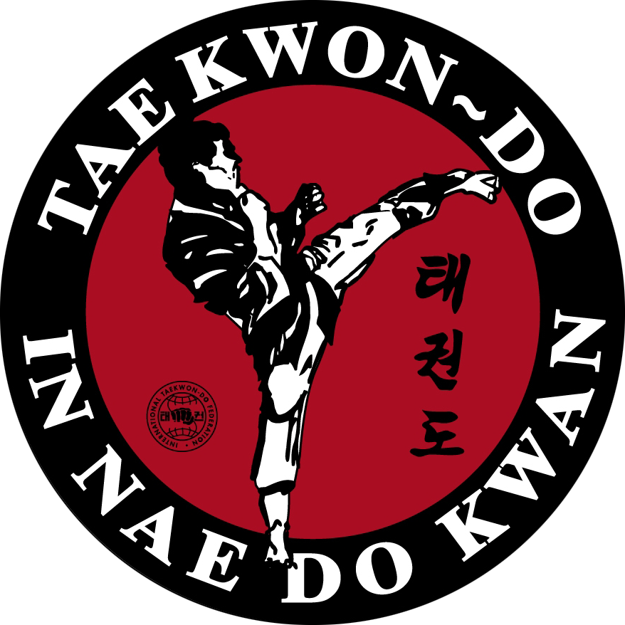
organization James Tjin-A-Ton
Henny van Zon
Liesbeth Willems
e-mail info@itf-taekwondo.nl
phone +31 6 54 277 369
web www.itf-taekwondo.nl

