5th PRESOV OPEN - OPEN SLOVAK CHAMPIONSHIP IN TAEKWON-DO ITF

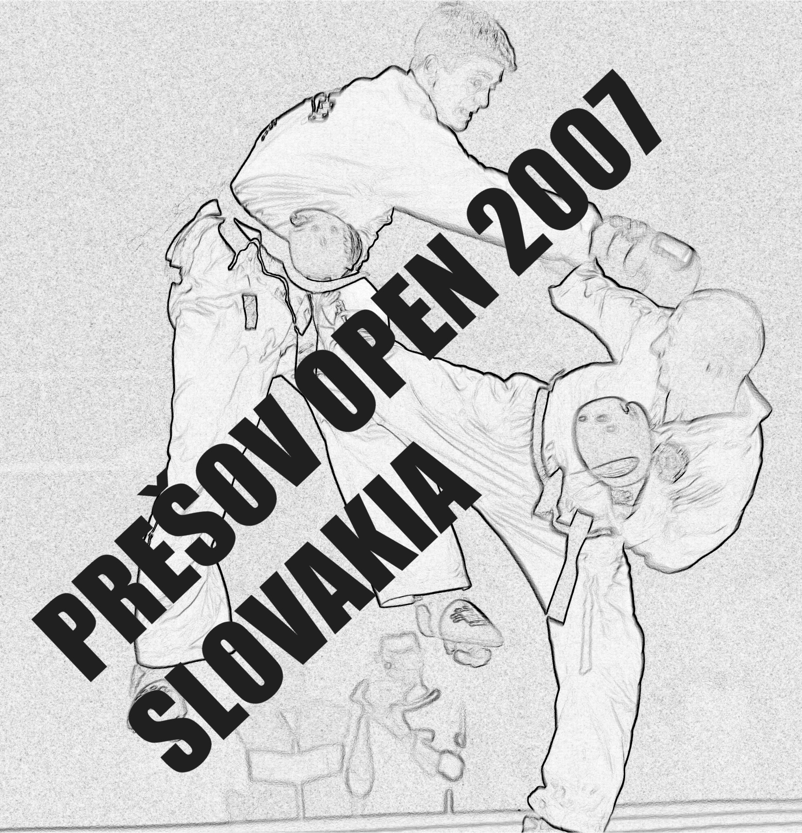

3. – 4. 2. 2007
SPORT HALL PU
PRESOV - SLOVAKIA

5th PRESOV OPEN - OPEN SLOVAK CHAMPIONSHIP
International Taekwon-Do I.T.F. Competition
Presov, Slovakia

February – 3rd – 4th, 2007
Presov, Slovakia

Dear President, Master or Instructor. This is to invite You to the 5th Presov Open Taekwon-Do ITF Competition. It will be held in Presov, Slovakia (East Slovakia) from February 3rd to 4th, 2007. The competition will be for children, juniors and seniors coloured and black belts, male and female. Event including: individual pattern, sparring and special technics.

We are looking forward to your participation.
Martina Soltisova Semesiova
The president of Slovak Union of Taekwon-Do ITF and Sport Club Taekwon-Do Ge-baek TJ Slavia PU Presov Slovakia

ORGANISER:
Slovak Union of Taekwon-Do ITF Slovakia
Plzenska 27, 080 01 Presov,
Corespondance: Bajkalska 12, 08001 Presov
tel: ++421 905 841128
fax: ++421 51 7745663
e-mail: msemesiova@gmail.com
www.sztkd-itf.sk
THE ORGANISER
OF THE 13th JUNIOR AND 22th SENIOR EUROPEAN TAEKWON-DO ITF CHAMPIONSHIP 2007
POPRAD – HIGH TATRAS
27. – 29. 4. 2007
www.sztkd-itf.sk/euros2007

COORGANISER:
Sport Club Taekwon-Do Ge-baek TJ Slavia PU Presov,
TJ Slavia PU in Presov,
Town office of Presov.

TOURNAMENT DIRECTOR:

Martina Tverdikova
tel: ++421 905 590 677
e-mail: martinatverdikova@centrum.sk

SPORT HALL AND ADDRESS:
The event will take place in the Sport hall PU
address: Sportova 10, Presov Slovakia

DIVISION/CATEGORIES:
- divisions/categories must consist of two or more competitors – if there is only one
competitor he/she will compete in a lower or higher category or division,
- black belts m/f, coloured belts m/f,
- children until 13 years (1994 can be), juniors junger (1993, 1992, 1991), juniors older (1990, 1989), seniors (from 1988 higher),
- the competitors have to have doctor control not older then 1 year.

PATTERN DIVISIONS CHILDREN/JUNIORS/SENIORS M/F:
- the competition is for competitors who has 9.kup and higher,
- pattern finals – one designated and one optional pattern,
- categories: 9-8 kup, 7-6 kup, 5-4 kup, 3-1 kup, 1 dan, 2 dan and so on.

SPARRING DIVISIONS – WEIGHT CATEGORIES M/F:
- from 6. kup and higher,
- juniors younger male: up to -48kg, -54kg, 60kg, -66kg, over-66 kg,
- juniors younger female: -45kg, -49kg, -53kg, -57kg, over 57kg,
- sparring eliminations and finals 2x2 minutes,
- juniors-older male:up to 52kg, -58kg, -63kg, -70kg, over 70kg,
- juniors-older female: up to 42kg, - 48kg, -53kg, -60kg, over 60kg,
- eliminations and finals 2x2 minutes,
- seniors male: -54kg, 54-63kg, 63-71kg, 71-80kg, over 80kg,
- seniors female: -52kg, 52-58kg, 58-63kg, 63-70kg, over 70kg,
- eliminations and finals 2x2 minutes.

SPECIAL TECHNICS
Technics | Children male | Children female | juniors younger male | Juniors younger female | Juniors older male | Juniors older female | Seniors male | Seniors female
Twimyo nopi apchagi | 190 cm | 175 cm | 230-250 cm | 190-210 cm | 240-260 cm | 200-220 cm | 260-280 cm | 220-240 cm
Twimyo dollyo chagi | 175 cm | 160 cm | 210-230 cm | 180-200 cm | 220-240 cm | 190-210 cm | 240-260 cm | 210-230 cm
- Twimyo jopcha jirugi | 165 cm | 150 cm | 200-260cm | 130-190 cm | 230-290 cm | 150-210 cm | 260-320 cm | 170-230 cm
- high | 50 cm | 40 cm | 50 cm | 40 cm | 60 cm | 50 cm | 70 cm | 60 cm

The organiser can change pattern and sparring divisions according to participation.

AWARDINGS – 1,2 and 2x3 places.

ENTRANCE FEE:
- 1 discipline: 500 Skk (slovak kroun),
- 2 disciplines: 600 Skk (slovak kroun),
- 3 disciplines: 700 Skk (slovak kroun).

INSURANCE:
- all competitors must have full insurance coverage for eventualities.

ACCOMODATION:
- We offer acc. in Pension Lineas, Budovatelska 14, Presov (very close to sport hall) – 750 Skk per night in doublebed room (it means: 375 Skk per person per night). And if you want – you can order a breakfast (60 Skk).

COACHES:
- Coaches must wear a training suit and gymnastic shoes and must accept and result given by the umpires as protest will not be accepted

UMPIRES:
- All clubs have to provide min. 1 umpire, if not, the penalty is 1000 Skk. Umpires have to wear the official dress. The organising committee will pay for umpires a meal and accomodation.

COMPETITORS SPORTS PROGRAM:
3. 4. 2007:
10:00 – 11:00 registration
11:00 – 11:30 coaches and umpires meeting
12:00 - 17:00 competition in pattern and special technics/weight in/medal awarding 17:00 – 18:00 accomodation
18:00 – X free time

4. 2. 2007:
8:30 – 9:00 coaches and umpires meeting
9:00 – 16:30 competition in sparring/medal awarding
17:00 – 17:20 official opening ceremony
17:20 – 19:00 finals/medal awarding

ENTRY FORMS:
- The following forms /competitor entry form and accomodation form/
must be send to:
Slovak Union of Taekwon-Do ITF Slovakia
Bajkalska 12, 08001 Presov
Fax: ++421 51 77 45663
E-mail: msemesiova@gmail.com
martinatverdikova@centrum.sk

- We accept only entry forms fill in PC
- We accept only slovak crouns

Registration deadline is on January 21th, 2007.

www.sztkd-itf.sk

