International Taekwon-do Tournament
MASTERS MAZOVIA CUP 2009



Ciechanow, 24th October 2009 r.

Announcement
- Name of the Championships:
  - International Taekwon-Do Tournament
MASTERS MAZOVIA CUP 2009
- Main Sponsor:
  - Marshal Office of Mazovia Voivoidship
- Support Sponsor:
  - Office of Ciechanow
- Honorary patronage:
  - Mr. Adam Struzik – Marshal of Mazovia Voivoidship.
  - Mr. Waldemar Wardziński – President of Ciechanow.
- Aim:
  - Promotion of Taekwon-do.
  - Promotion of Ciechanow City and Mazovia Area in Poland and abroad
- Main Organizer:
  - LKS Matsogi Ciechanow Club.
- Organizers:
  - Polish Taekwon-Do Association
  - MOSiR Ciechanow.
- Media patronage:
  - Radio KRC Ciechanów 103,9 FM
  - Newspapers: Tygodnik Ciechanowski and Czas Ciechanowa
- Term:
  - 23rd-25th October 2009 r.
- Weigh in and registration:
  - „Baron” Hotel Śląska Street 11, 23rd October 2009 (Friday), from 4 to 8.00 p.m
- Venue of the competition:
  - Hala Sportowa MOSiR in Ciechanow, 17-go Stycznia Street 60
- Prizes:
  - Financial reward for all competitors in each category for , 1st , 2nd , 3rd place!
  - Financial reward for clubs in medal classification as follows: I- 200 Euro, II- 150 Euro, III- 100 Euro!
  - Medals for 1st , 2nd , 3rd place.
  - Cups for competitors for the 1st place and for the clubs for 1st , 2nd , 3rd place.

- Accommodation and board:
  - Hotel „Baron” Śląska 11 Street, about 700 meter from the sport hall.
  - Hotel „Olimpijski” 17-go Stycznia 60 Street, nearby the sport hall
  - Triple – four people rooms with bathroom - 20 Euro per person/a day.
  - Double rooms with bathroom - 30 Euro per person/a day.
  - Single rooms with bathroom - 40 Euro per person/a day
  - Prices include board (first 24 hours: supper, breakfast, dinner;
second 24 hours: party, breakfast
- Tournament timetable:
23rd October 2009 r. (Friday)
from 2.00 p.m - arrival of competitors
6.00 p.m - 8.00 p.m - weight in and doctor’s examination („Baron” Hotel),
8.30 p.m - 9.00 p.m - coach meeting
9.00 p.m - 9.30 p.m - umpire meeting
24th October 2009 r. (Saturday)
07.00 a.m - 8.00 a.m - breakfast (in hotels)
10.00 a.m - 3.00 p.m -qualifiers
03.00 p.m - 5.30 p.m -break
05.30 p.m -meeting of competitors participating in the Gala MMC 2009
06.00 p.m - 8.00 p.m - GALA MASTERS MAZOVIA CUP 2009
9.00 p.m - Party at Baron Hotel
25th October 2009 r. (Saturday)
08.00 a.m – 10.00 a.m - breakfast (at a hotel)
till 12.00 - departure
Attention! During the competition participants may go swimming, use jaccuzi, slider and water massages for free!
- Patrticipation conditions:
  - Entry fee :
    - 10 Euros per competitor in each competition
  - At the MMC 2009 can take part only
    - members of ITF
    - competitors having min. 2 cup
    - Organizer has a right to collect a fee of 10 Euros from competitors, which will not be accommodated at a hotel offered by the Organizer
- Competition Rules
  - The championships will be player according to the rules of ITF and PTA
  - Age of competitors: seniors, born in 1991 and older,
- Divisions
- INDIVIDUAL SPARRING
- Female sparring(2 kup – VIth Degree): -63 kg, +63 kg,
- Male sparring (2 kup – VIth Degree): -63 kg,-71 kg, +71 kg;
- Qulifers in groups of 3-5 competitors (2 rounds x1,5min),
- Finals and Semifinals will be playd at Gala MMC 2009, (2 roundsx2min)
- INDIVIDUAL MALE PATTERN 2CUP-Ist DEGREE
- INDIVIDUAL MALE PATTERN IInd DEGREE-VIth DEGREE
- INDIVIDUAL FEMALE PATTERN 2nd cUP-Ist DEGREE
- INDIVIDUAL FEMALE PATTERN IInd DEGREE- VIth DEGREE
- The competition will be played in the traditional „pyramid system”
- Competitors will perform two patterns: first chosen by them, the second one obligatory

- TRADITIONAL SPARRING
- Performance should last about 1 min.
- The competition will be player in TRADITIONAL „pyramid system”
- Male and female may perform.
- Final and semifinal will be player during Gala MMC 2009
- FEMALE SPECIAL TECHNIQUE( only nopi ap cha busigi)
- MALE SPECIAL TECHNIQUE ( ONLY nopi ap cha busigi)
- Competitors per form only nopi ap cha busigi,
- 3 best female and male competitors will go to to Gala MMC 2008, minimum height: male – 240 cm, female - 200 cm
- Competitors may start at any height
- Competitors may have two trials at each height
- Financial reward system:
  - Number of participants x 20 euro= 100% of the amount
  - Ist place 50% amount
  - IInd place 30% amount
  - IIIrd place 20% Mount
  - When there is more than 16 competitors in sparring category, the Winner receive 100 Euros extra!
- Other matters:
  - The competitors have to be in possession of safety equipment: boxing gloves (10 OZ), kicks – foot safety pads, ITF dobok, groin guards must be worn inside the dobok trousers – male only
  - There have to be at least 4 competitors, pairs in every category. In case if there will be less then 4 competitors in category, the organizers have right to cancel the category
  - The Chairman of the Competition will decide about the matters not written in this announcement.
  - There is possibility to arrange transport from the Warsaw Airport to Ciechanow and back – ca. 20 Euro.
- Applications:
  - Applications have to be send before or on the 10th October 2009 to the e-mail address: mkorzybski@wp.pl
  - The person responsible for the organization is: Mr. Michal Korzybski:
mobile phone: +48607133234 or email: mkorzybski@wp.pl
  - In case of any question please contact Master Jerzy Jedut:
mobile +48603133228 or email jjedut@pztkd.lublin.pl
The competitors have to be insured
In case of after-effect of unfortunate accidents.
We are looking to see you in Ciechanow!
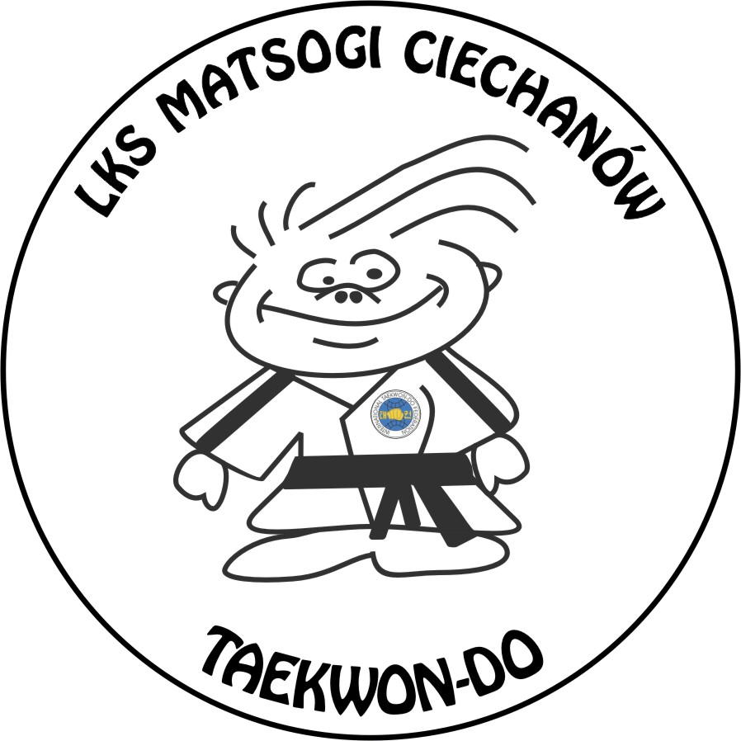

Michał Korzybski
Organizer

